THE AMERICAN STYLE
POPULAR MUSIC IN THE UNITED STATES

Popular music is music that is disseminated widely. As such, it has been particularly significant with the twentieth-century proliferation of recording technologies and mass media. Sometimes we may forget that it was not until the 1920s that recording, and playback technology allowed for the spread of music through records. To become popular before that time, a tune had to be spread by word of mouth, by traveling performers, and by music notation, which might appear in a music magazine or newspaper or in sheet music that could be bought at general stores, catalogs, and music stores.
Today the success of a popular music artist is most often measured by how many songs they sell. In the past, that meant record and CD sales, but today it essentially means numbers of downloads. Recording industry executives determine which artists to record and distribute based almost entirely on their perceived ability to sell units. Most popular music today is sold by downloading it to an electronic device, though CDs are still manufactured and distributed.
Popular music is also often thought of as ephemeral, that is, as remaining in the consciousness of a group of people for a limited time. For this chapter, we have chosen popular music that has either transcended that boundary or that was so important in or exemplary of its time and place that its discussion helps us understand music, history, and culture more broadly. It is, however, but a sampling of a huge body of popular music that exists in the United States since roughly the colonial period. As you listen to these examples, perhaps you can think of similar examples of popular music that you know.

Jazz is a uniquely American style. American orchestral composers were becoming aware of jazz in the early twentieth century, and George Gershwin (1898-1937) was no exception. Gershwin was a brilliant talent who dropped out of school at the age of fifteen to begin a professional career playing piano in New York’s “Tin Pan Alley.” After several years of success as a performer and composer, he was asked by the famous band leader Paul Whiteman to compose a work that would help raise people’s perceptions of jazz as an art form. The resulting work, Rhapsody in Blue, combines the American blues style with the European symphonic tradition into a brilliant composition for piano and orchestra. Listen to how beautifully Gershwin combines these elements via the link below.

Gershwin, Rhapsody in Blue (1924) https://www.youtube.com/watch?v=BxowOVIdnR0

In addition to Rhapsody in Blue, George Gershwin is also known for his opera, “Porgy and Bess.” Although not a true opera in the strict sense of the term (Gershwin dubbed it a “folk opera”), the piece is considered one of the great American operatic works of the century

George Gershwin – “Summertime” https://www.youtube.com/watch?v=O7-Qa92Rzbk

American born Aaron Copland (1900-1990) was instrumental in helping to define a distinct American sound by combining his European musical training with jazz and folk elements. As an early twentieth-century composer, Copland was active during the Great Depression, writing music for the new genre of radio, the phonograph, and motion pictures. El Salon Mexico (1935), Fanfare for the Common Man (1942), and Appalachian Spring (1944) are three of Copland’s most famous works. He won a Pulitzer Prize for his music for the ballet Appalachian Spring and was also an Oscar-winning film composer. Appalachian Spring is a ballet depicting a pioneer wedding celebration in a newly built farmhouse in Pennsylvania. It includes the now well-known Shaker song Simple Gifts.

Copland, Appalachian Spring (1944) https://www.youtube.com/watch?v=ZNHWcHEMy-Q

Aaron Copland, Rodeo (1942)
One of the ways in which Copeland was able to capture the sense of vastness of the American landscape was through his use of certain harmonic intervals, that is, two notes played together, which sound “hollow” or “open.” These intervals, which are called “perfect 4ths” and “perfect 5ths,” have been used since medieval times, and were named so due to their simple harmonic ratios. The result is music that sounds vast and expansive. Perhaps the best example of this technique is found in Copland’s famous Fanfare for the Common Man.
While fanfares are typically associated with heralding the arrival of royalty, Copland wanted to create a fanfare that celebrated the lives of everyday people during a trying time in American history. The piece was premiered by the Cincinnati Symphony Orchestra on March 12, 1943 at the height of World War II. To this day, no other piece stirs up patriotic emotions like Fanfare for the Common Man. It has been used in countless movies, television shows, and even military recruitment ads. The piece came to define Copland’s uniquely American compositional style and remains one of the most popular patriotic pieces in the American repertoire.

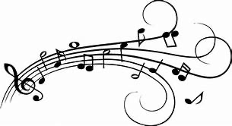

POPULAR MUSIC IN THE UNITED STATES

Popular music is music that is disseminated widely. As such, it has been particularly significant with the twentieth-century proliferation of recording technologies and mass media. Sometimes we may forget that it was not until the 1920s that recording, and playback technology allowed for the spread of music through records. To become popular before that time, a tune had to be spread by word of mouth, by traveling performers, and by music notation, which might appear in a music magazine or newspaper or in sheet music that could be bought at general stores, catalogs, and music stores.

The musical styles that have developed in the United States are as varied as the people who live here. In this chapter, we learned that ragtime, New Orleans jazz, and the blues are all critical to the creation and growth of the popular music we enjoy today. We learned about the emphasis on rhythm inherited from African roots, and that syncopation refers to accented notes that are not on the beat. We also learned that from the country’s colonial beginnings to the present day, the musical, societal, and cultural establishment has not always approved of popular music—particularly ragtime, blues, and jazz.

Scott Joplin and others developed the distinct style that was called “ragtime,” which contributed, along with other African American music styles to the formation of jazz in and around New Orleans. We saw Louis Armstrong rise to international fame as a jazz performer, recording artist, and movie star. This was followed by the “big bands” of the 1930s and 1940s, and later the small groups, or combos that performed the highly sophisticated music known as bebop. We discussed the evolution of rhythm and blues (R&B) into modern R&B and learned to identify rap music as a style based on two central elements: a strong rhythmic beat and lyrics. We explored the wide variety of folk songs in America. We also learned that folk music in America largely developed from music of the British Isles and Europe, as well as the music brought here by African slaves. We also investigated how rock music incorporated the blues and an emphasis on beats two and four borrowed from jazz to create an exciting new music that appealed to the youth culture.

In the realm of country music, we learned about bluegrass music, which developed largely in the Appalachian region, as well as honky-tonk and hillbilly music, both of which were variations of country music. We examined Western swing as a subset of country music that often uses dance band instruments.

Today, American musical theatre takes the form of the Broadway musical, which features a strong plot conveyed through dialogue and supported by song and dance. We also discussed American opera in the form of Gershwin’s folk opera, Porgy and Bess.

The importance of American popular music of the twentieth century cannot be overstated. Genres such as rock and roll and rap have now been exported around the globe. At their root, all forms of American popular music have been influenced by the blues, and thus owe their existence to the cultural contributions of African Americans. Although America was not yet discovered during much of the early development of Western art music, we have contributed much to the culture of the world in a relatively short span of time
RAGTIME MUSIC

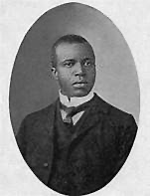
Scott Joplin
Author: Unknown
Source: Wikimedia Commons
License: Public Domain

The style of piano playing known as “ragtime” greatly influenced the development of American popular music. Indeed, all our popular music styles grew out of ragtime and its New Orleans based cousin, jazz. Before the establishment of the recording industry, musicians supplied all live musical entertainment and background music. Music for these musicians to play was published in its written form for piano and other non-electric instruments. Ragtime was first published as written piano sheet music in the 1890s; by the early 1900s, it had almost taken over the music publishing industry. In fact, ragtime was so popular that it even increased the sale of pianos and energized the early music recording industry.

One of the most important ragtime composers, Scott Joplin was born sometime late 1867 and early 1868, probably in the northern part of Texas. Although most of the details of his early life are uncertain, his name appears in the 1880 census, listing him as twelve years of age. His father was a former slave and his mother worked in the home of a well to do white family in Texarkana. Scholars believe that Joplin probably had access to a piano in the home of his mother’s employer and began at that time to learn the rudiments of music. While in Texarkana, Joplin’s ability gained notice, and he began to study with Julius Weiss, a German-born music teacher. Scott later attended high school in Sedalia, Missouri then alternated between Texarkana, where in 1891 he was performing with a minstrel show, and Sedalia, where for several years he continued to perfect his compositional technique. In 1899, he convinced Civil War veteran, music lover, and music store owner John Stark to publish “Maple Leaf Rag”— a piece destined to become the most popular ragtime composition. By 1914, it had sold over 1 million copies.

Maple Leaf Rag – Scott Joplin https://www.youtube.com/watch?v=fagH03fxY7c
The Entertainer – Scott Joplin http://www.youtube.com/watch?v=t9gzZJ344Co

Arthur Pryor was the most famous trombone soloist of his era and a member of the world-renowned band of John Philip Sousa. Prior was born in Missouri and wrote numerous successful ragtime compositions. When the Sousa Band toured Europe in 1900, Arthur Pryor’s ragtime compositions did much to spread the fame of ragtime to Europe. By the early 1900s, ragtime enjoyed tremendous popularity and could be found in many different forms, including the early example of mass-produced recorded music, the phonograph record. Listen to the following phonograph recording of the Sousa Band from 1906.

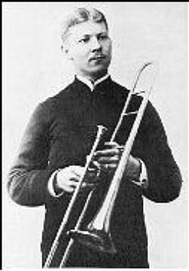
Arthur Pryor
Author: Unknown
Source: Wikimedia Commons
License: Public Domain

John Phllip Sousa Band, “Arkansas Huskin’ Bee” http://www.youtube.com/watch?v=JCDhpPGzCC4

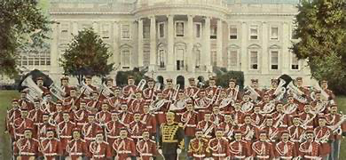
John Phillip Sousa First Band Festival
Public Domain
Author: Unknown

THE BLUES

The term “the blues” may have originated in two possible ways. The first possibility is that as early as the 1790s the term “blue devils” was used to refer to feelings of suffering and sadness. The term first appeared in print in Hart Wand’s piece, “Dallas Blues” (1912), the first copyrighted blues composition. The second possibility suggests it derives from the mysticism associated with many West African cultures that used the Blue Indigo plant to dye the garments of those who were in mourning after the death of a loved one. The indigo plant was grown on many Southern plantations, and its use could have strengthened the slaves’ connecting “blue” indigo with suffering.

Whatever the source, the term “the blues” became universally associated with a style of music that at the turn of the twentieth century began to form out of African American work songs, field hollers, and spirituals. Today, the word “blues” is used loosely and can mean several different things, like feeling sad or down. It can also describe any song played in a bluesy style.

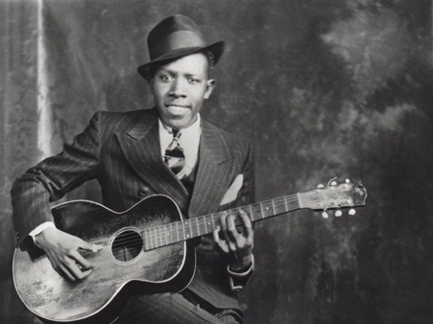
Robert Johnson/
Author: User “Aneodote”/
Source: Wikipedia/
License: Fair Use

The term “blues” most commonly describes a song that follows a blues form, which is a twelve-bar strophic song form. This musical structure of the blues has influenced the development of jazz, rock, techno, and other popular styles of music and is based on a few basic and recurring compositional and performance techniques. The form of the blues is repeating. It is usually eight, twelve, or sixteen bars in length, although some pieces vary this somewhat, and those sections are repeated several times. The blues uses a limited number of chords, usually three or four. Specific notes within these chords are often lowered (the third, fifth, and seventh notes above the root of the chord), and the scales associated with these “blue note” alterations are called “blues scales.” Musicians often “bend” the pitch of these notes to give them their bluesy quality.

Robert Johnson – “Cross Road Blues” https://www.youtube.com/watch?v=GsB_cGdgPTo
BB King - “How Blue Can You Get” https://www.youtube.com/watch?v=6jCNXASjzMY

More than any other musical style, the blues is the foundation of all American music. It appears in virtually every other native musical style, including jazz, rock, rhythm and blues, and hip hop.

JAZZ MUSIC

New Orleans has, for centuries, been a city of many different cultural and ethnic groups. French, Spanish, Italian, German, and Irish immigrants all settled there before and during the 1800s, and it is in this city where their musical styles mixed with the different musical influences infused by the descendants of African slaves. New Orleans jazz has its roots in Storyville, an area of New Orleans (NOLA) known for its bars, dance halls, and brothels—like Missouri’s Chestnut Valley. In the early part of the 1900s, African American musical styles such as ragtime, blues, spirituals, and marches merged to create a unique art form. Although jazz borrows much of its harmony and instrumentation from Europe, it differs fundamentally from European styles in its rhythmic makeup. Jazz emphasized syncopation and swing. Swing is a term used to describe the rhythmic bounce that characterizes the jazz style.

One of the most important aspects of the jazz style is that it often depends on performers being able to improvise. Improvisation is the act of creating melodies and harmonies on the spot without reading the music off a page. The blending of written and improvised performance has become an integral part of jazz performance and has continued in the later evolution of rock and other popular styles. Early jazz musicians learned to improvise entire new melodies over the chord structures of existing tunes.

By the early 1900s, dance music group instrumentation had changed from mostly string orchestras to jazz bands using instruments borrowed from marching bands; the band instruments were louder and more suited to noisy dance halls. Different combinations of trumpets, clarinets, saxophones, trombones, and tubas joined with drums, piano, guitar, and banjo to form the common jazz band instrumentation. However, piano players often traveled from city to city looking for work and it is easy to see how the music of these popular ragtime pianists influenced early jazz development in NOLA.

In 1917, Storyville was closed due to the efforts of religious leaders in NOLA, so jazz musicians were forced to move to Chicago, New York, Los Angeles, Memphis, St. Louis, and other big cities to find work. Around this same time, the recording industry began to flourish, particularly in Chicago and New York. Soon groups like the Original Dixieland Jazz Band began recording New Orleans style jazz. Jazz eventually became part of a performing and recording revolution that swept the country (and Western world) and changed popular music and culture forever.

Charles “Buddy” Bolden is widely recognized as the first major figure in the early development of jazz in NOLA. Bolden, like most of the other top jazz performers at that time, was of African descent, a fact which points to the central importance of African Americans to the development of New Orleans jazz and later American popular music from this point forward. Unfortunately, no known recordings of Bolden exist. The Original Dixieland Jazz Band, an ensemble comprised of white musicians, is widely considered to have made the first recording of jazz. This recording sold over one million copies in the first six months of its release and did much to associate New Orleans with “jazz” in the new recording industry. Phonograph records soon replaced sheet music as a favorite way to experience new music because records allowed the listener to hear the subtle jazz performance practices that could not be accurately put down on paper.

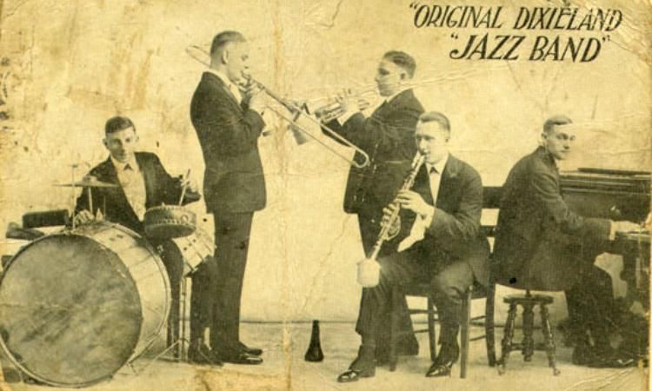
Original Dixieland Jazz Band
Author: Unknown
Source: Wikimedia Commons
License: Public Domain

This early style of jazz, now known as New Orleans Jazz, or “Dixieland,” is based almost entirely on the tradition of improvisation. The mature Dixieland style was in full swing by the 1920s and included syncopated rhythms, improvised solos, and harmonies, as well as a common instrumentation that included trumpet, clarinet, saxophone, trombone, tuba, banjo, piano, guitar, and drums. The form of most Dixieland tunes, like almost all popular music, was based on repeated sections.

Glenn Miller – “In the Mood” https://www.youtube.com/watch?v=_CI-0E_jses

Louis Armstrong

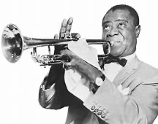
Louis Armstrong
Author: World-Telegram Staff
Source: Wikimedia Commons
License: Public Domain

The late 1920s saw the rise of a New Orleans native who transformed jazz from a somewhat loose style with many parts being improvised at the same time, into a style that featured soloists taking turns playing improvised solos. Louis Armstrong, whose nickname was “Satchmo,” became an international jazz superstar and movie and television personality in a career that stretched from the 1920s to the 1960s.

Armstrong was born in 1901 in a section of New Orleans with a violent reputation, so much so that it was called “The Battlefield.” At the age of 11, Armstrong was arrested for firing a gun in the air to celebrate the New Year and was subsequently sent to the Colored Waif’s Home for Boys. It was here that Armstrong learned to play the cornet (an early version of the trumpet). He quickly realized his aptitude for music and, upon being released two years later, soon began to build a reputation as one of the best trumpet players in New Orleans, performing everywhere from the seedy bars of Storyville to the riverboats that traveled up and down the Mississippi River.

Armstrong eventually moved to Chicago to join the band of his old mentor, Joe “King” Oliver. From 1925 to 1928, Armstrong made a series of recordings as a leader known as the “Hot Fives” and “Hot Sevens” that would cement his status as one of the most important jazz artists of the twentieth century. His innovations include the following: he established jazz as a solo art form firmly rooted in the blues and which celebrated individual expression; he introduced a jazz singing style, which included a loose phrasing style; he defined the new rhythmic feel of jazz known as swing; and he expanded the possibilities of the trumpet through bends and other techniques that allowed him to mimic the human voice.

For audio, go to: https://www.youtube.com/watch?v=W232OsTAMo8

In addition to common Dixieland instrumentation and improvised solos, this selection also contains a vocal solo by Louis Armstrong using a technique called “scat singing.” Scat singing occurs when a vocalist improvises a melody using seemingly nonsense syllables, often to imitate the style of a wind instrument. Louis Armstrong was the originator of “scat singing.”

No unit on New Orleans jazz would be complete without mentioning the Marsalis family. Father Ellis (piano) and sons Branford (saxophone), Wynton (trumpet), Delfeayo (trombone), and Jason (drums) are all artists of the first rate and world-renowned as individual jazz musicians.

Struttin’ With Some Barbeque – The Marsalis Family https://www.youtube.com/watch?v=gUnWt21HxMQ

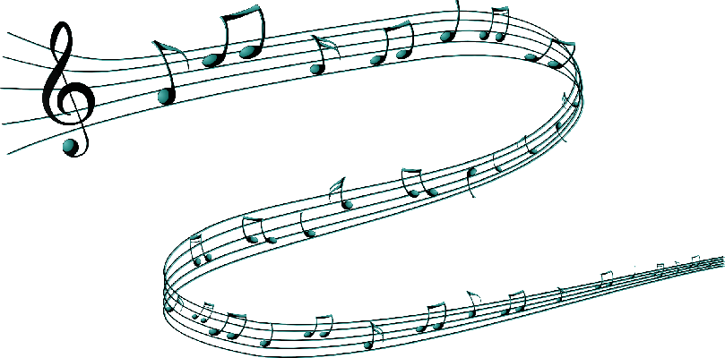
Duke Ellington

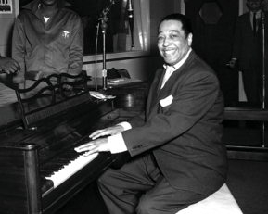
Duke Ellington
Author: Unknown
Source: Wikimedia Commons
License: Public Domain

An originator of big-band jazz, Duke Ellington was an American composer, pianist and bandleader who composed thousands of scores over his 50-year career. A major figure in the history of jazz music, Duke Ellington's career spanned more than half a century, during which time he composed thousands of songs for the stage, screen, and contemporary songbook. He created one of the most distinctive ensembles sounds in Western music and continued to play what he called "American Music" until shortly before his death in 1974. Born on April 29, 1899, Ellington was raised by two talented, musical parents in a middle-class neighborhood of Washington, D.C. At the age of seven, he began studying piano and earned the nickname "Duke" for his gentlemanly ways. Inspired by his job as a soda jerk, he wrote his first composition, "Soda Fountain Rag," at the age of 15. Despite being awarded an art scholarship to the Pratt Institute in Brooklyn, New York, Ellington followed his passion for ragtime and began to play professionally at age 17.
Ellington sought out musicians with their own personal sounds to incorporate into his orchestra. Some famous musicians from the Ellington band include trumpeter Cootie Williams, who created interesting vocal effects with a plunger mute; Cat Anderson, who could hit high notes that most trumpeters thought impossible, and alto saxophonist Johnny Hodges, a master at bending notes to create beautiful expressive melodies. Ellington was able write music that wove these unique playing styles together into a musical tapestry that was complex and dissonant, yet beautiful and accessible. Ellington wrote many big band hits of the 1930s and 1940s, such as the example below, “It Don’t Mean A Thing If It Ain’t Got That Swing.”

For audio, go to: https://www.youtube.com/watch?v=YbwDRdRXP3k
Glenn Miller – “In The Mood”
One of the most important figures in the big band era was Duke Ellington, a bandleader and composer who created some of most unique and innovative sounding music of the era. Ellington sought out musicians with their own personal sounds to incorporate into his orchestra. Some famous musicians from the Ellington band include trumpeter Cootie Williams, who created interesting vocal effects with a plunger mute; Cat Anderson, who could hit high notes that most trumpeters thought impossible, and alto saxophonist Johnny Hodges, a master at bending notes to create beautiful expressive melodies. Ellington was able write music that wove these unique playing styles together into a musical tapestry that was complex and dissonant, yet beautiful and accessible. Ellington wrote many big band hits of the 1930s and 1940s, such as the example below, “It Don’t Mean A Thing If It Ain’t Got That Swing.”
Audio

Composer: Duke Ellington
Composition: It Don’t Mean A Thing If It Ain’t Got That Swing
Date: 1931 (recorded 1932)
Genre: Big Band Jazz
Form: AABA
Nature of Text: an upbeat song celebrating swing music
Performing Forces: Early Big Band Instrumentation:
Arthur Whetsel, Freddie Jenkins, Cootie Williams – trumpet; Joe Nanton, Juan Tizol – trombone; Barney Bigard, Johnny Hodges, Harry Carney – woodwinds; Duke Ellington – piano, Fred Guy – banjo; Wellman Braud – bass; Sonny Greer

Stan Kenton was an innovative big band leader who liked to incorporate music from other cultures into his repertoire. Listen to the Latin influence in his recording of “Malaga.”

Stan Kenton – “Malaga” https://www.youtube.com/watch?v=HEt13RIL0ko

This recording of the Count Basie band is a great example of the traditional swing style of jazz in a contemporary arrangement of “Sweet Georgia Brown.”

Count Basie – “Sweet Georgia Brown” https://www.youtube.com/watch?v=EbbBeU1vHew

Numerous vocalists also became stars in the Big Band movement. One of the most famous also became a movie star: Frank Sinatra.
Frank Sinatra – “New York, New York” https://www.youtube.com/watch?v=odNmQiSC6dY

Ella Fitzgerald became world famous as a jazz vocalist and recording artist and enjoyed a long and illustrious career as one of the leading jazz recording artists of all time.
Ella Fitzgerald – “The Lady is a Tramp” https://www.youtube.com/watch?v=k9mssKqk6YE

The big band tradition continues to this day with vocal artists such as Michael Bublé recording and performing live concerts. Here Michael Bublé performs his hit “Moon Dance.”
Michael Bublé - “Moon Dance” https://www.youtube.com/watch?v=PBCJWJXeFzk

BEBOP JAZZ ERA
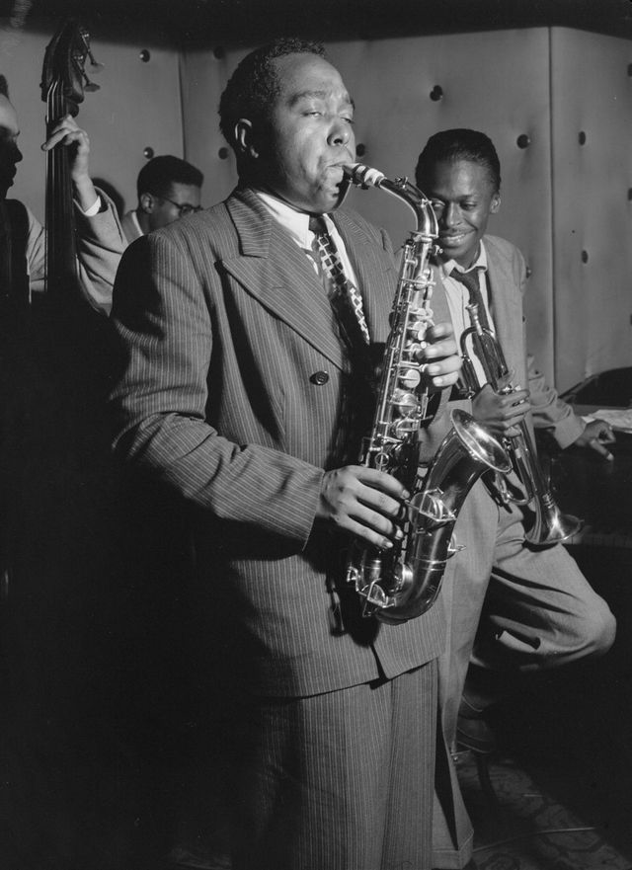Charlie Parker, Tommy Potter, Miles Davis, Dizzy Gillespie and Max Roach, Three Deuces, New York, New York/. Author: William P. Gottlieb,/ Source: Wikimedia Commons/ License: Public Domain
In the early 1940s, World War II had put a serious damper on saloons and dance halls due to rationing, lower incomes, and the drafting of many musicians. It was difficult for bandleaders to hire enough good players because many musicians had gone to war. Consequently, many musicians began to form smaller jazz ensembles consisting of a few wind instruments and a rhythm section. These ensembles are often called jazz “combos.”

At this same time, several important musicians, including Dizzy Gillespie, Bud Powell, and Thelonious Monk, began meeting at such clubs in uptown New York City as Minton’s Playhouse. During late night jam sessions, they began exploring new ways to improvise in a small group setting. The bebop style developed when Charlie Parker arrived in New York from Kansas City. His nickname was “Bird,” and he soon became perhaps the most influential bebop player. Bebop was a dramatic departure from the jazz that came before it in several ways. The music featured more complex, faster moving harmonies, angular melodies, and highly complex rhythms that were not conducive to dancing. Most importantly, bebop marked the beginning of the modern jazz era. From this point on, jazz was no longer perceived as a popular music. Dance halls gave way to basement clubs where jazz enthusiasts would come to sit and listen. While jazz never regained its initial popularity, musicians such as John Coltrane, Miles Davis, and others carried on the jazz tradition into the 1950s and beyond, creating some of the most groundbreaking recordings in American music.

In the late 1960s and 1970s, some acoustic jazz musicians became interested in incorporating electronic instruments and rock beats into the jazz idiom. This style is often called fusion as its “fuses” jazz with other styles. A truly outstanding group from this era is Weather Report. The composition entitled “Birdland” from Weather Report’s 1977 Heavy Weather studio album, Heavy Weather received numerous awards, as well as ranking #1 on the Billboard jazz charts. Although the title of the song pays tribute to an acoustic jazz club in New York City named after Charlie Parker, the music itself features a rock instrumentation, a straight beat, and electronic instruments. The group’s bass player Jaco Pastorius is considered by many to be the best electric bassist of all time.

Charlie Parker – “Donna Lee” https://www.youtube.com/watch?v=02apSoxB7B4

In the late 1960s and 1970s, some acoustic jazz musicians became interested in incorporating electronic instruments and rock beats into the jazz idiom. This style is often called fusion as it “fuses” jazz with other styles. A truly outstanding group from this era is Weather Report. The composition entitled “Birdland” from Weather Report’s 1977 Heavy Weather studio album, Heavy Weather received numerous awards, as well as ranking #1 on the Billboard jazz charts. Although the title of the song pays tribute to an acoustic jazz club in New York City named after Charlie Parker, the music itself features a rock instrumentation, a straight beat, and electronic instruments. The group’s bass player Jaco Pastorius is considered by many to be the best electric bassist of all time.

Weather Report – “Birdland” https://www.youtube.com/watch?v=cH-WXR-Y2xs

RHYTHM AND BLUES
The term “rhythm and blues (R&B)” was first used by Billboard magazine in 1948 to refer to music recorded by black musicians and intended for use by the African American community. It has changed definitions several times over the years and is now very much in the mainstream. At one point, the term encapsulated several different musical styles, including soul and funk. Early rhythm and blues ensembles often featured a twelve-bar blues form with a strong backbeat (emphasis on beats two and four.) These early groups typically consisted of a rhythm section augmented by a saxophone or background vocalists. Georgia native Ray Charles was one of the early innovators of R&B. “Contemporary R&B” generally refers to music with jazz, gospel, and funk roots that uses electronic instruments, drums, horns, and vocals. T

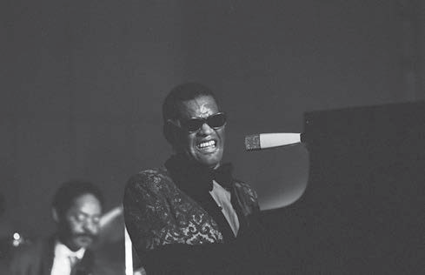

Ray Charles
Author: Heinrich Klaffs
Source: Wikimedia Commons
License: CC BY-A 2.0

Ray Charles – “Hit the Road Jack” https://www.youtube.com/watch?v=Q8Tiz6INF7I&list=PL4417733726B17D

“Contemporary R&B” generally refers to music with jazz, gospel, and funk roots that uses electronic instruments, drums, horns, and vocals. This Earth, Wind & Fire example of contemporary R&B includes a rock rhythm section, brass, and synthesizer—plus a great groove. Many other excellent examples exist from groups like Kool and the Gang and The Ohio Players.

Earth, Wind & Fire – “In the Stone” https://www.youtube.com/watch?v=rNNaK0hSkrA

ROCK AND ROLL
Early rock and roll grew directly out of the tradition of rhythm and blues. The term “rock and roll” is widely credited to the disk jockey Alan Freed, who used it to describe the R&B records he played on Cleveland’s WJW radio station. Rock and Roll was marketed and consumed primarily by a teenage audience. Eventually, the term “rock and roll” was shortened to “rock” and evolved into an all-encompassing international music with a wide variety of subgenres such as glam rock, heavy metal, new wave, and grunge.

The cultural impact of rock and roll has been massive, influencing almost every facet of popular culture, from fashion to language. Although early rock and roll bands often featured a variety of wind instruments such as the saxophone, by the 1950’s, the typical rock and roll band was defined by the electric guitar. Invented in 1931, the instrument used an electronic device called a pickup to convert the vibration of the strings into electronic signals run to a speaker. The earliest electric guitars were merely used as a means of amplification, but rock and roll guitarists began to experiment with various effects, such as distortion that would alter the sound of the instrument.

Chuck Berry – “Rock and Roll Music” https://www.youtube.com/watch?v=0XSaKQlBZuE

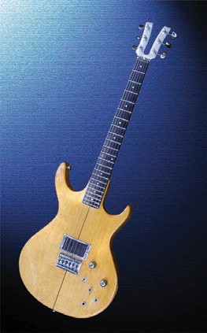
Electric guitar, solid body, Kramer XKG-20 circa 1980
Author: User “Bellwether Today”
Source: Wikimedia Commons
License: CC BY SA 4.0

Elvis Presley
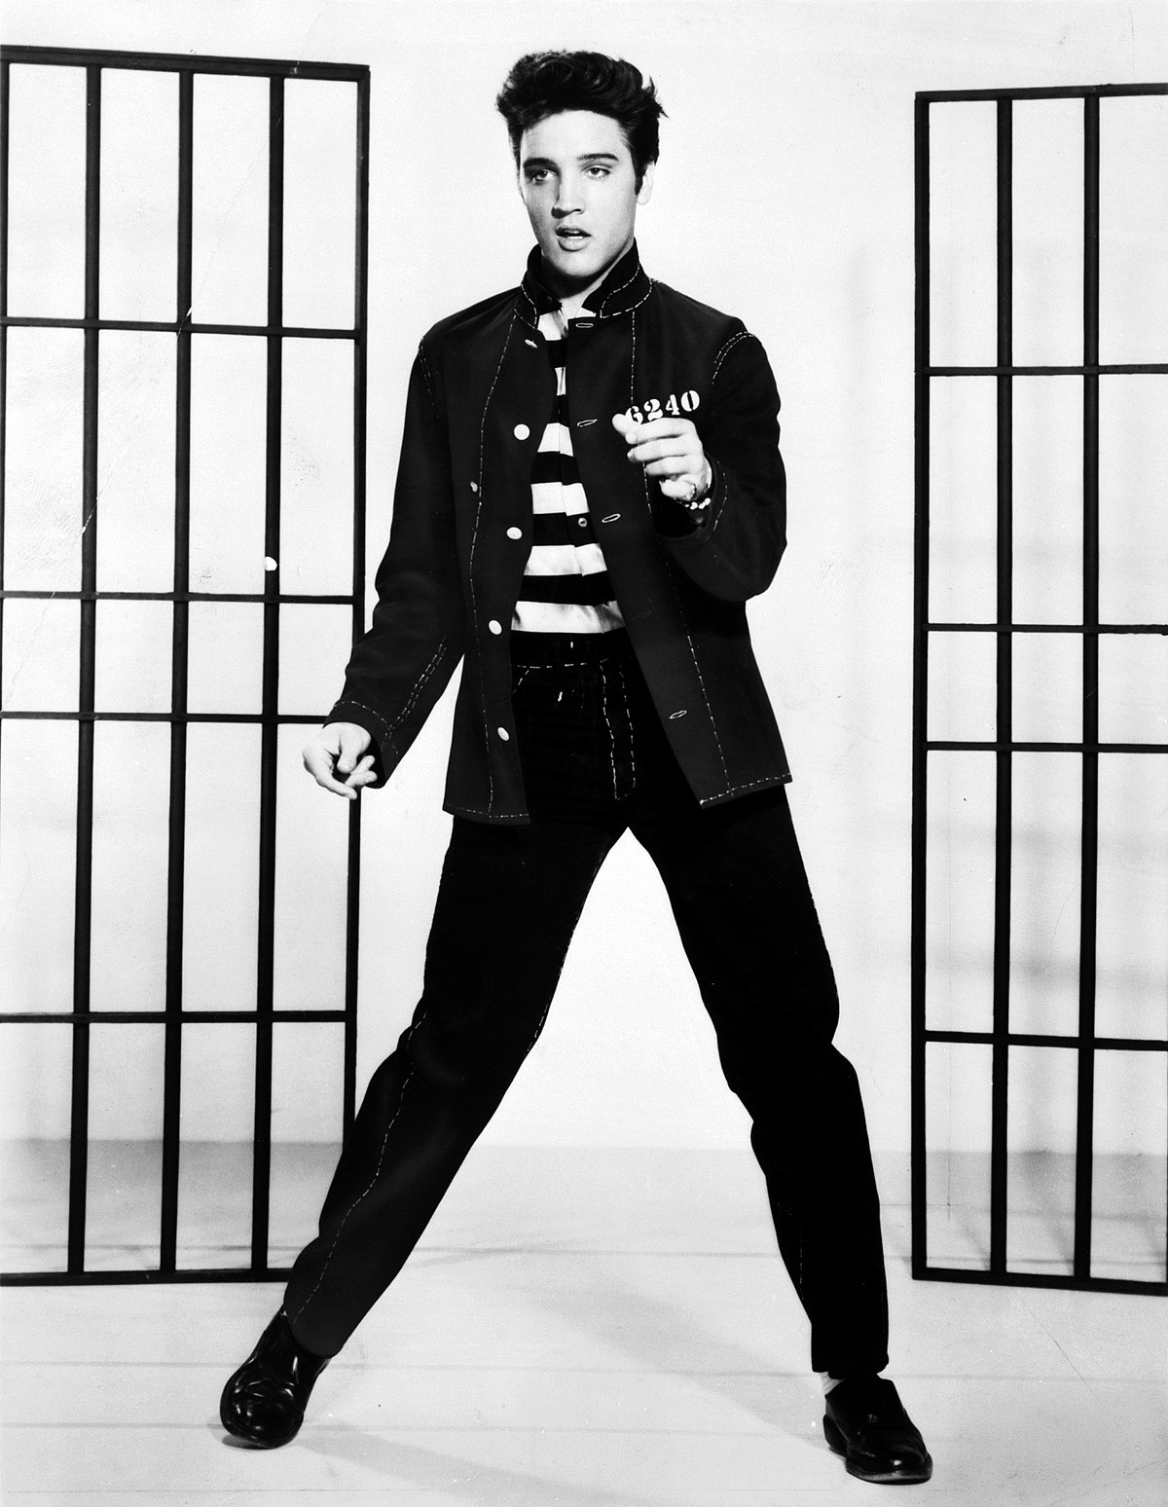
Elvis Presley
Author: Metro-Goldwyn-Mayer, Inc.
Source: Wikimedia Commons
License: Public Domain

Elvis Presley was one of the most important figures in the history of rock and roll, and one of the most celebrated recording artists of the twentieth century. He was born in Tupelo, Mississippi but grew up in Memphis, Tennessee. His recording career began in Memphis in 1954 when he worked with Sam Phillips, the owner of Sun Records. Elvis combined the sounds of country music and rhythm and blues into a style that was initially called rockabilly. Elvis soon moved to the RCA label, and his first single record “Heartbreak Hotel,” released in 1956, became the number one hit in the United States. By embracing music from both sides of the civil rights movement, Elvis became both very popular and very controversial at the same time. In many ways, he helped bring the popular music of African Americans into the mainstream of white society and paved the way for groups like the Beatles and the Rolling Stones, who were heavily influenced by black artists. Elvis later branched out and recorded many successful ballads and rock tunes. He died of a drug overdose in 1977. Listen to the blues influence in Elvis’s singing and the guitar and piano solos in “Heartbreak Hotel.”

For audio, go to: https://www.youtube.com/watch?v=e9BLw4W5KU8

One of the most famous rock and roll groups of all time was The Beatles. This British group toured the United States in 1964 and changed the face of popular music and the recording industry from that time forward. The Beatles popularized the use of electric guitars as the basis of the modern rock band and went on to add strings, brass, organ, and other instruments to the list of instruments used in rock performances and recordings. Their use of straight eighth notes on the cymbals and accents on beats two and four on the snare drum are classic rock and roll rhythm elements. Most Americans are unaware of the influence that Chuck Berry and other American artists had on the style and content of the Beatles’ music.

The Beatles – “I Want To Hold Your Hand”
https://www.youtube.com/watch?v=o1_zdt_FNmM

RAP MUSIC
Rap is a form of spoken word delivered over a beat. It can be improvised or written out in advance. The history of rap music is intertwined with the history of hip hop and even disco music. An excellent history of hip hop and rap can be found on the Hiphop-Network site linked below.

http://www.hiphop-network.com/articles/general/kurtisblowversionofhiphop.asp

While the origins of rap can be traced back to Africa, rap as we know it came into being in the Bronx, NY in the 1970s. However, not until the art form was recorded did it enter the cultural mainstream. One of the first important rap recordings was the 1979 hit, “Rapper’s Delight” by the Sugarhill Gang. Kurtis Blow (Kurt Walker, born August 9, 1959) is the first rapper to sign with a major record label. “The Breaks,” a single from his 1980 debut album, is the first certified gold record rap song.
By the 1990s, rap had evolved into a more sophisticated musical style featuring complex rhythms and clever wordplay. The instrumentation of rap music varies greatly depending on the artist and, often, the individual song. Early rap concerts featured DJs creating beats on turntables, which allowed the DJ to create music on the spot by playing and manipulating records. One well-known technique on the turntables is scratching or improvising a rhythmic solo on one turntable over a beat.

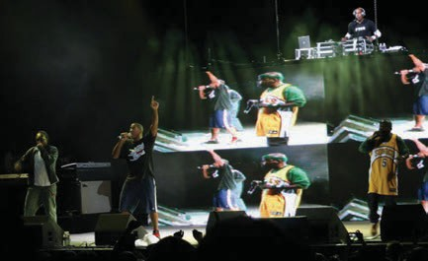
A Tribe Called Quest
Author | James Chutter
Source | Wikimedia Commons
License | CC BY 2.0
Kurtis Blow - “The Breaks” (1980) https://www.youtube.com/watch?v=MAk2wlv1N1I

For audio, go to: https://www.youtube.com/watch?v=71ubKHzujy8

Audio

Composer: A Tribe Called Quest (Q-Tip, Ali Shaheed Muhammad, Phife Dawg, Jarobi White)
Composition: “Can I Kick It”
Date: 1990
Genre: Rap
Form: Verse-chorus
Nature of Text: recited to a steady beat
Performing Forces: Rap vocals over looped music backdrop incorporating a variety of musical samples from previous recordings
Rappers: Q-tip and Phife Dawg
STYLES & VARIETY OF MUSIC
Country Music

Like many musical terms discussed in this chapter, Country Music has come to define a broad variety of musical styles encompassing Bluegrass, Hillbilly Music, and Contemporary Country among others. Most types of music that fall under this category originated in the American South (although it also encompasses Western Swing and cowboy songs) and features a singing style with a distinctly rural southern accent, as well as an instrumentation that favors string instruments such as the banjo, guitar, or fiddle.

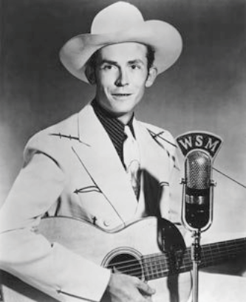
Hank Williams
Author | WSM radi
Source | Wikimedia Commons
License | Public Domain

Bluegrass music
Bluegrass music is a variation of country music that developed largely in the Appalachian region; it features fiddle, guitar, mandolin, bass guitar, and the five-string banjo. Often associated with Appalachia, bluegrass combines many of the song forms that are common in the region’s Scottish/English musical heritage. For example, bluegrass blends the Scottish/English ballad with blues inflections. Some bluegrass songs are fast instrumental pieces featuring amazing technique by the performers. Listen to Ricky Skaggs and the Bluegrass Thunder perform via the link below.

Hillbilly music was an alternative to the jazz and dance music of the 1920s. It was portrayed as wholesome and as the music of the “good old days.” Nashville’s Grand Ole Opry radio show became a very successful weekly network radio broadcast heard nationwide. Noticing an opportunity, record companies soon opened offices in Nashville. Country music became a source of big money for producers, song writers, and artists.

Honky-tonk music developed as Hillbilly music went west to entertain in saloons called “honky tonks.” Many of the songs dealt with subjects associated with honky tonks, such as infidelity and drinking. Although the first use of the term “honky tonk” referred to a ragtime-like piano style, it later came to refer to a country combo style that became quite popular in the 1940s and 1950s.

Western Music refers to music composed about the Great American West, such as the cowboy songs heard in movies of the 1930s and 1940s by singers such as Gene Autry and Roy Rogers. One variation of this genre, Western swing, developed in Austin, Texas and other western cities and borrowed instruments from the dance band (saxophones, trombones, trumpets, piano, bass, and drums).

Musical Theatre -The term musical theatre refers to a type of dramatic performance that tells a story through dialogue, with singing and dancing added to support and move the plot along. This differs from opera, which is presented purely through song, without any spoken word. One precursor to modern musical theatre is the minstrel show. The first distinctly American form of theatre, minstrelsy was developed in the nineteenth century and featured white performers in blackface performing in a variety show of sorts. These three-act shows featured stock characters singing songs, performing in skits, and telling jokes. They often depicted black characters as happy participants in romanticized versions of the American slave south. One of the most well-known songwriters of minstrel music was Stephen Foster. Listen to his song Camptown Races, which depicts a group of men in a “camp town” (a community of transients) who bet on horses to try to make money.

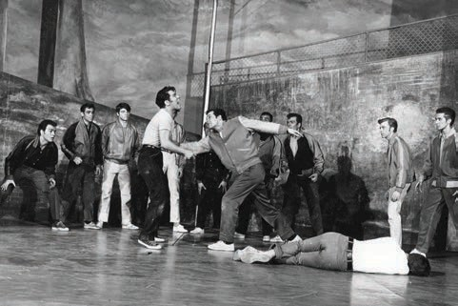
West Side Story
Author: Fred Fehl
Source: Wikimedia Commons
License: Public Domain
Audio
Composer: Leonard Bernstein
Composition: America from West Side Story
Date: 1957
Genre: Broadway Musical
Form: Verse-chorus
Nature of Text: The Puerto-Rican characters lament on the dream of living as an immigrant in America versus the reality.
Performing Forces: Orchestra with solo vocals and chorus
What we want you to remember about this composition:
- The piece is written in mixed meter, alternating between 6/8 time and 3/4 time
- It features Latin American rhythms and percussion

Broadway Musicals - During the twentieth century, the operetta slowly gave way to a more cut-and dry, vernacular American musical theatre style, which continues today. Modern musical theatre (also known as the Broadway musical) integrated a cohesive plot with songs and dances that advanced that plot. This more direct musical style reflected the American audiences of the twentieth century, who were less interested in the formal, Victorian style of the operetta. Musicals are stage shows with music, acting, costumes, sets, and dance. They are closely related to opera and are an American art form, though they are also popular in parts of Europe. Some successful musicals were later turned into movies. Musicals usually use a full Romantic orchestra and often add synthesizer sounds as well. Listen to and watch the following segment from one of the most successful musical productions in Broadway history.

Phantom of the Opera - “All I Ask of You” https://www.youtube.com/watch?v=uxs7qevmy50

American Opera - Although not a true opera in the strict sense, George Gershwin’s “folk opera” Porgy and Bess is considered one of the great American operatic works of the century. The story is set in a tenement in Charleston, South Carolina. Based on DuBose Heyward’s novel Porgy, the opera incorporated classically trained black singers to depict the tragic love story between the two main title characters. Gershwin based the music for the opera on elements of folk music, drawing on southern black musical style such as the blues and spirituals. Drawing on the nineteenth century opera tradition, Gershwin made use of leitmotifs to represent people or places. Near the beginning of the opera, we hear the famous aria “Summertime,” which depicts the hot, hazy atmosphere in which the story is set.

George Gershwin – “Summertime” https://www.youtube.com/watch?v=O7-Qa92Rzbk

Summary of the Twentieth Century

The musical styles that have developed in the United States are as varied as the people who live here. In this chapter, we learned that ragtime, New Orleans jazz, and the blues are all critical to the creation and growth of the popular music we enjoy today. We learned about the emphasis on rhythm inherited from African roots, and that syncopation refers to accented notes that are not on the beat. We also learned that from the country’s colonial beginnings to the present day, the musical, societal, and cultural establishment has not always approved of popular music—particularly ragtime, blues, and jazz.
Scott Joplin and others developed the distinct style that was called “ragtime,” which contributed, along with other African American music styles to the formation of jazz in and around New Orleans. We saw Louis Armstrong rise to international fame as a jazz performer, recording artist, and movie star. This was followed by the “big bands” of the 1930s and 1940s, and later the small groups, or combos that performed the highly sophisticated music known as bebop. We discussed the evolution of rhythm and blues (R&B) into modern R&B and learned to identify rap music as a style based on two central elements: a strong rhythmic beat and lyrics. We explored the wide variety of folk songs in America. We also learned that folk music in America largely developed from music of the British Isles and Europe, as well as the music brought here by African slaves. We also investigated how rock music incorporated the blues and an emphasis on beats two and four borrowed from jazz to create an exciting new music that appealed to the youth culture.
In the realm of country music, we learned about bluegrass music, which developed largely in the Appalachian region, as well as honky-tonk and hillbilly music, both of which were variations of country music. We examined Western swing as a subset of country music that often uses dance band instruments and recognized contemporary country music as a mixture of rock and country styles.
America was also home to a wide variety of styles of musical theatre. From the minstrel songs of Stephen Foster, which glorified the plantation South, to the operettas of Victor Herbert, which dominated musical theatre at the turn of the nineteenth century, America has a rich history of song and dance. Today, American musical theatre takes the form of the Broadway musical, which features a strong plot conveyed through dialogue and supported by song and dance. We also discussed American opera in the form of Gershwin’s folk opera, Porgy and Bess.
The importance of American popular music of the twentieth century cannot be overstated. Genres such as rock and roll and rap have now been exported around the globe. At their root, all forms of American popular music have been influenced by the blues, and thus owe their existence to the cultural contributions of African Americans. Although America was not yet discovered during much of the early development of Western art music, we have contributed much to the culture of the world in a relatively short span of time.

GLOSSARY
Ballads – a song form used often in folk music, which is used to tell a story that usually contains a moral or lesson.
Bebop a style of small group jazz developed in the late 1940s, which featured fast moving harmonies, angular melodies, and highly complex rhythms
Big Band – large jazz ensembles (15-20 members) popular in the 1930’s and 1940’s. The term “Big Band” also refers to the era in which these bands were popular.
Bluegrass – a variation of country music featuring fiddle, guitar, mandolin, bass guitar, and the five-string banjo that developed largely in the Appalachian region
Blues – a style of music that, at the turn of the twentieth century, began to form out of African American work songs, field hollers, and spirituals. Today, the word “blues” is used loosely and can refer to feeling sad or down, to any song played in a bluesy style, or more specifically, to a song that follows a blues form, which is a twelve-bar strophic song form.
Broadway Musical – a style of Musical Theatre, which integrated a cohesive plot with songs and dances that advanced that plot. Broadway specifically refers to the street of the same name in New York City that became known for this style.
Children’s Song – a type of folk song designed to teach a simple lesson. They are often simple to sing and easy to remember.
Contemporary Country – a mixture of rock rhythm sections and a singer singing with a country accent about many of the same topics that traditional country singers have used over the decades.
Contemporary R&B – generally refers to music with jazz, gospel, and funk roots that uses electronic instruments, drums, horns, and vocals.
Country Music – a term describing a broad variety of musical styles including Bluegrass, Hillbilly Music, and Contemporary Country. Most types of music that fall under this category originated in the American South (although it also encompasses Western Swing and cowboy songs) and features a singing style with a distinctly rural southern accent, as well as an instrumentation that favors string instruments such as the banjo, guitar, or fiddle.
Dance Music – music written for dancing. The instrumentation of various types of folk dance music varies with the style.
Dixieland – an early form of jazz developed in New Orleans during the turn of the twentieth century featuring syncopated rhythms, improvised solos, and harmonies, as well as a common instrumentation that included trumpet, clarinet, saxophone, trombone, tuba, banjo, piano, guitar, and drums.
Folk Music – a term used to describe a wide variety of musical forms that developed within different cultures, often for different reasons. Folk music is often passed down not through written music, but orally from one generation to another.
Hillbilly Music – an early form of country music, Hillbilly Music was an alternative to the jazz and dance music of the 1920s and was portrayed as wholesome music of the “good old days.”
Honky Tonk Music – a country combo style that became quite popular in the 1940s and 1950s. Originally performed in saloons known as “honky tonks,’ many of the songs dealt with subjects associated with honky tonks such as infidelity and drinking.
Improvisation – the act of creating melodies and harmonies on the spot without reading the music off a page.
Minstrel Show – an American form of theatre developed in the nineteenth century and featuring white performers in blackface performing in a variety show, which depicted black characters as happy participants in romanticized versions of the American slave south.
Musical Theatre – a type of dramatic performance that tells a story through dialogue, with singing and dancing added to support and move the plot along.
New Orleans Jazz – (see Dixieland)
Operetta – a “light opera” developed in the nineteenth century that required classically trained singers but featured less complex music than a typical opera.
Protest Song – a type of folk song written to directly, or by suggestion, voice complaints about some injustice.
Ragtime – a musical genre developed near the turn of the twentieth century that featured syncopated rhythms. The style became nationally popular after being widely published as sheet music.
Rap – a form of spoken word delivered over a beat. It can be improvised or written out in advance.
Rhythm and Blues (R&B) – a term originally referring to music recorded by black musicians and intended for use by the African American community. The term has evolved throughout the years and encompasses several different musical styles, including soul, funk, and now contemporary R&B.
Rock and Roll – a style of music that grew out of Rhythm and Blues and came into prominence during the 1950s. The style features a strong backbeat and often features electric guitar, bass and drums. The style is now known as “rock” has spawned many subgenres.
Sampling – a technique in which a clip of a preexisting song is isolated and looped, often as a background for a rapper
Scratching – the technique of improvising a rhythmic solo on one turntable over a beat
Swing – a term used to describe the rhythmic bounce that characterizes the jazz style. The term can also refer to the big band music of the 1930s and 1940s.
Syncopation – the act of disrupting the normal pattern of accents in a piece of music by emphasizing what would normally be weak beats.
Western Swing – a style of country music that developed in western cities and borrowed instruments from the dance band such as saxophones, trombones, trumpets, piano, bass, and drums.
Work Songs – a type of folk song devised to help groups of people perform physical work. The music usually uses the tempo of the work itself and was sung by lumberjacks, railroad workers, and prison chain gangs, among others.

