Title of assignment: Compare and Contrast
Length [to be filled out by instructor]: 3-5 pp
Due date [to be filled out by instructor]: TBA

SLO:

- Define judgement and criteria that are appropriate to the objects of evaluation/comparison
- Evaluate using these judgment and criteria
- Produce a compare and contrast essay

Description of assignment:

Compare and contrast essays and the objects, phenomena, and/or ideas that they describe are an important kind of paper—they offer a chance to see beyond binaries and to view things in a complex and nuanced way. So, for this assignment, we will choose two related subjects or subjects which are often grouped together and describe in detail their similarities and differences.

But in order to see in this nuanced way, it is important to see the objects of comparison for what they are—therefore, the sections on Evaluation will prove useful.

Goal of assignment:

The goal of this assignment is to see two subjects in a more rich and detailed way in order to uncover why these two subjects are often grouped together or why they should be. At the same time, this paper also asks you to see how these subjects are complex and should be viewed with all their nuances and differences. We are, in short, making a paper out of a Venn Diagram, where similarities and differences are described, as illustrated below, where the overlap between the circles signifies the similarities between two subjects.

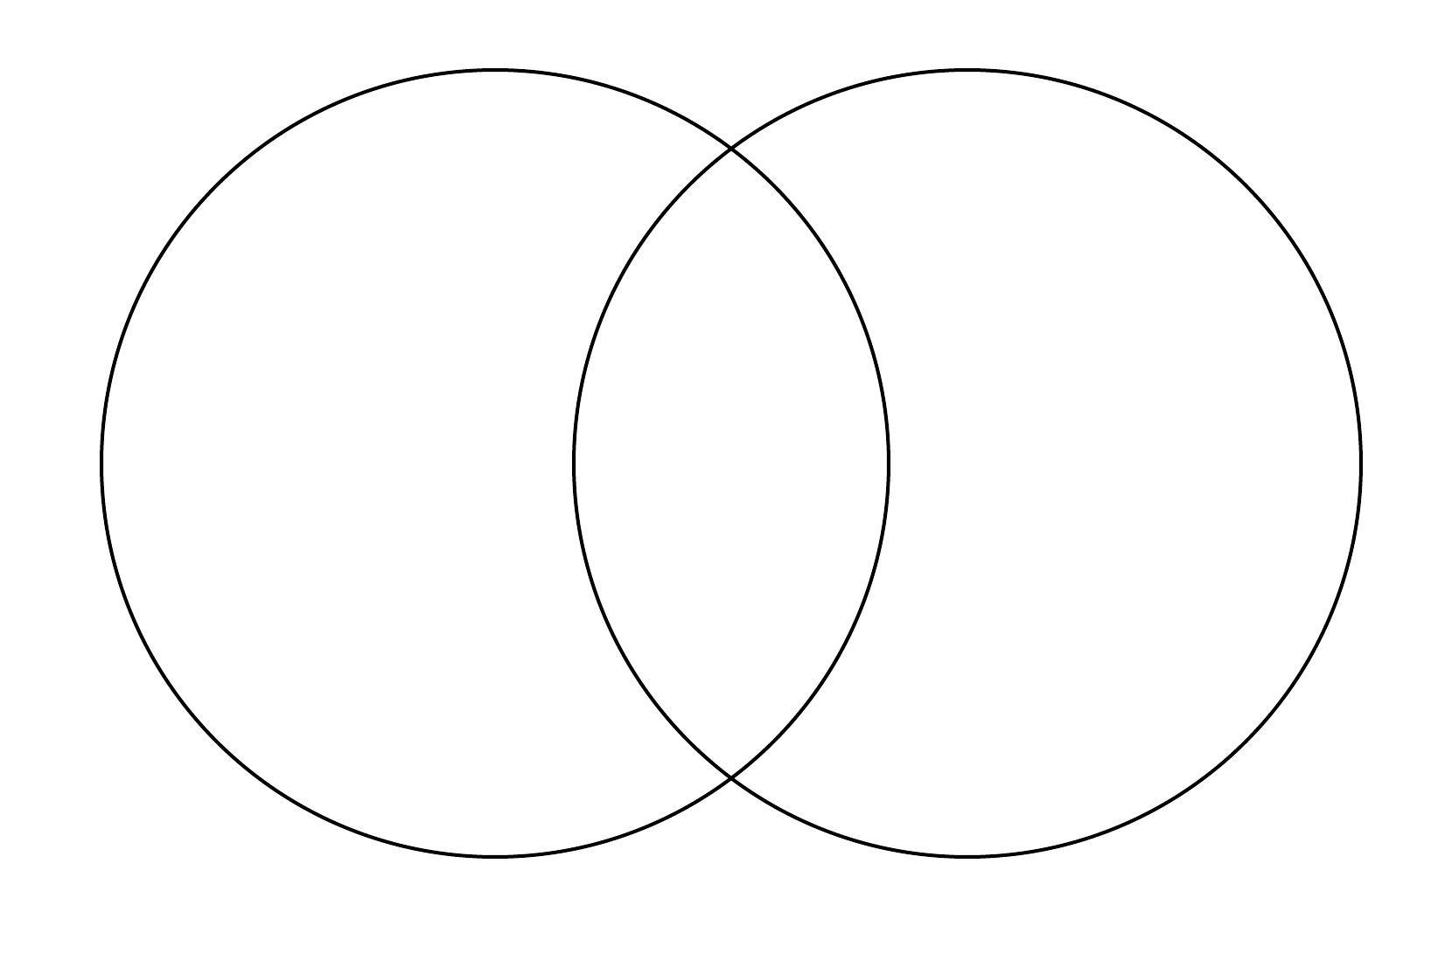

Skills we will work on with this paper:

--Observation and description

--Argumentation

--thesis creation

--Organization

--Use of transitional words

Suggestions for topics:

Historical Events: The French and American Revolutions

Technology and Social Media: Twitter and Facebook

People: Beyoncé and Madonna

Ideas: Evolution and Creationism

Rubric [with percentage breakdown for different aspects of evaluation/grade (%)]:

Purpose & Supporting Details (30 points possible)

Clear contrast and comparison/
specific examples/relevant information 30 points

Clear contrast and comparison/
General examples/relevant information 20 points

Fairly clear contrast and comparison/ 10 points
General examples/includes non-relevant information

Incomplete contrast and comparison/
Missing examples/includes non-relevant information 5 points

Organization and Structure (30 points)
Organization follows consistent order, with logical
connections between similarities and differences 30 points

Organization doesn’t always follow a consistent order
but logical connections between and differences
are present 20 points

Organization doesn’t follow a consistent order
and logical connections are missing 10 points

Little sense that the comparison and contrast
is organized 5 points

Thesis (20 points)

Thesis explains the contrast and comparison,
highlights the importance of the comparison/contrast 20 points

Thesis explains the contrast and comparison,
gestures to the importance of the comparison/contrast 15 points

Thesis explains the contrast and comparison,
and the importance of the comparison/contrast
is implied 10 points

Thesis doesn’t explain contrast and comparison,
and makes passing reference to the importance of the comparison/contrast 5 points

Grammar and Formatting (20 points)

no errors in grammar or spelling that
distract the reader from the content,
MLA formatting is correct 20 points

A few errors in grammar or spelling that
distract the reader from the content,
MLA formatting is correct 15 points

Multiple errors in grammar or spelling that
distract the reader from the content,
Some MLA formatting is incorrect 10 points

Errors mostly distract the reader from content,
MLA formatting is missing or mostly incorrect 5 points

Possibilities (the best essays do this):
--present a logical and connected discussion of similarities and differences, avoiding lists of things that are similar or dissimilar
--choose subjects to compare and contrast that are similar enough to warrant the comparison and different enough to create a compelling argument.
--make clear the “so-what” of the essay—why does this comparison and contrast matter? The most advanced essays address the relevance of these comparisons and contrasts in explicit and implicit ways

Perils (common mistakes students make with this assignment):

--a data dump of similarities and differences that appear as lists
--choosing things that are too different or too similar
--not addressing why these similarities and differences are important

