EXPLORING INTERACTIONS OF MATTER WITH LIGHT

This assignment supports the following Course Goals, Course Learning Outcomes, and Unit Objectives:

- Identify the Properties of Electromagnetic Radiation (CLO3)

PART 1: GETTING STARTED
- Download the Molecules and Light simulation:
http://phet.colorado.edu/en/simulation/molecules-and-light
Click on the play to run the simulator

- Explore all of the controls in the simulation for about 5 minutes. Click on different things and figure out what each one does. What are some of your observations?

PART 2: “LIGHT” IN THE SIMULATION
Rank the electromagnetic radiation in the simulation in terms of energy, wavelength, and frequency.
- Energy

- Wavelength

- Frequency

PART 3: INTERACTION OF LIGHT AND MATTER
- Examine how different photons in the simulation affect each molecule. Record your observations for each combination in a few descriptive words.

 | Microwave | Infrared | Visible Light | Ultraviolet
CO
N₂
O₂
CO₂
H₂O
NO₂
O₃

- Which molecule(s) were not affected by any of the radiation in the sim?
Why might this be important? (Hint: think about what molecules are commonly found in our air and atmosphere)

- Examine your observations above and summarize the effects of each kind of radiation on the molecules in the simulation.

 | Microwave | Infrared | Visible Light | Ultraviolet
Effect(s) on
Molecules

PART 4. MOLECULES IN THE SIMULATION

The interaction of light with a molecule depends on characteristics of the molecule. The presence of nonbonding lone-pair electrons or bond dipoles are two examples. Identify at least 2 more characteristics.

PART 5: GENERALIZED OBSERVATIONS
Return to your earlier classification and try to identify molecular characteristics associated with a particular interaction with electromagnetic radiation.

Type of Radiation | Which Molecules were affected?  Hint: Drawing Lewis structures may help. | General Rule to Predict Activity
Microwave
Infrared
Visible
Ultraviolet

PART 6: PREDICTING REACTIVITY WITH LIGHT

Consider the molecule assigned to your group and predict how it will interact with light based on your observations in the simulation with other molecules.
Hint: It may be helpful to use the “Molecule Polarity” simulations to explore the shape and polarity of your molecule: http://phet.colorado.edu/en/simulation/moleculepolarity

Assigned Molecule | Microwave | Infrared | Visible | Ultraviolet

Investigating critical angle and Total Internal Reflection using a PhET simulation

STEP1: Go to https://phet.colorado.edu/en/simulation/bending-light , click on the  button. Choose ‘Intro’ and set it up so that it looks like the screenshot below. The material in the top half should be water, the material in the bottom half should be air, and the angle of incidence should be about 30°. 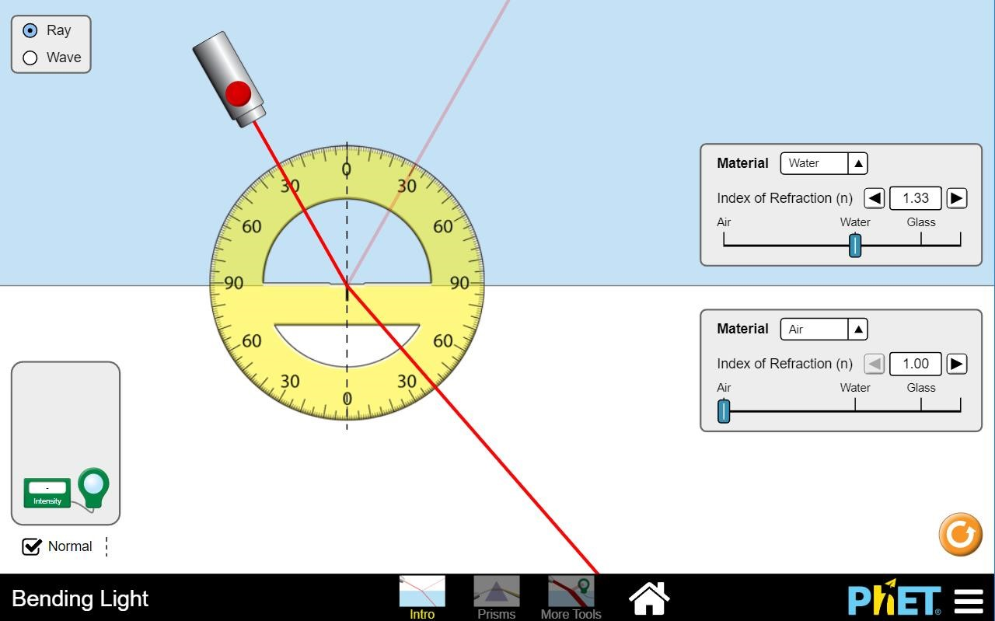

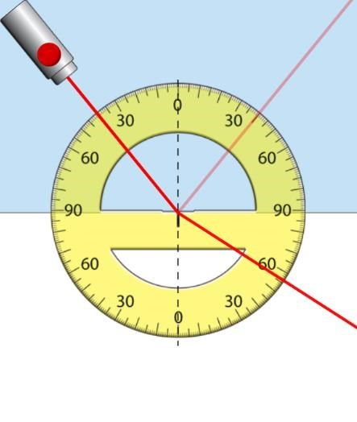
STEP 2: Gradually increase the angle of incidence until i = 40°.
The cropped screenshot on the right should help.
Read off and record the angles of reflection and refraction below.

Angle of reflection = …………………°

Angle of refraction = …………………°

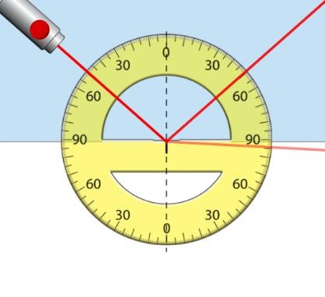
Step 3: Keep increasing the angle of incidence until the angle of refraction is as close to 90° as you can get it. (See the cropped screenshot below)
If you increase the angle of incidence further then the refracted ray will disappear.
The angle when this happens is called the “critical angle” for water.
Record the critical angle for water here:
Critical angle for water = …………………°

Step 4: Return the angle of incidence to 0° and change the material in the top half to glass. Repeat step 3 to find the critical angle for glass.
Record it here:
Critical angle for glass = …………………°

Step 5: Repeat the process to find the critical angle for material Mystery A and Mystery B.
Record the results here:
Critical angle for Mystery A = …………………° Critical angle for Mystery B = …………………°

Step 6: Put the critical angle results into the table below and complete the other columns using the instructions below the table.
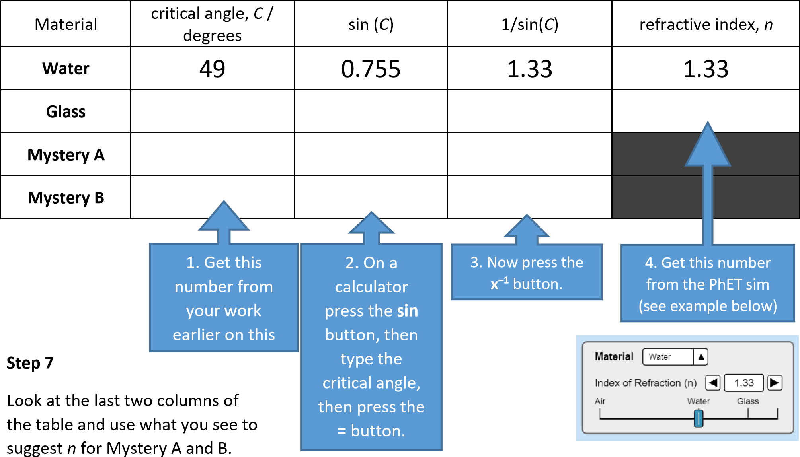
refractive index for Mystery A = ……………………………………… ; refractive index for Mystery B = –……………………………………

Task B

Step 1: Set the PhET sim up so that it looks like the screenshot below.
The material in the top half should be water, the material in the bottom half should be air, and the angle of incidence should be 10°. Catch the reflected ray with the intensity meter as shown in the screenshot.

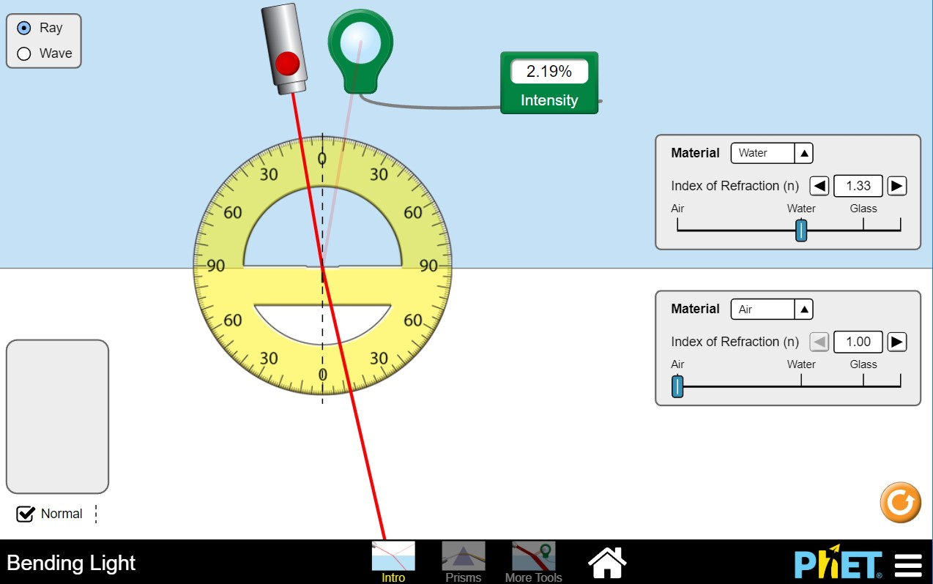

angle of  incidence  / degrees | intensity of  reflected ray  / %
10 | 2.19
20
30
35
40
45
50
55
60
70
80

Step 2
Increase the angle of incidence by 10°, catch the reflected beam with the intensity meter to find out what % intensity the reflected beam has. Record your result in the table on the right.
Step 3: Complete the rest of the table by making measurements from the sim.

Step 4: When the angle of incidence is greater than the critical angle, 100% of the light intensity is reflected. This is called total internal reflection because all the light is reflected.
Use the data in the table to suggest a value for the critical angle in water, and explain why you have chosen that angle.
…………………………………………………….…………………………………………………….……………………………………………………………………….
…………………………………………………….…………………………………………………….……………………………………………………………………….

