Electricity and Electrical Circuits

  - Define: static electricity (CLO2)(CLO3)
  - Determine the type of electric charge present (CLO2)(CLO3)(CLO4)
  - State units of charge and electric force in SI units. (CLO2)(CLO5)
  - Describe interactions between charges and electric fields. (CLO2)(CLO3)
  - Use Coulomb’s Law to calculate electric force (CLO5)
  - Use Ohm’s Law to solve simple circuit problems (CLO5)
  - Describe and differentiate between parallel and series electrical circuits. (CLO2)(CLO3)
  - Determine the equivalent resistance for series and parallel combinations of resistors. (CLO2)(CLO5)
  - Determine the frequency, electric resistance, voltage, and electric current in a simple AC circuit (CLO2)(CLO3)(CLO5)
  - Explain the function of a coil, resistor, and capacitor in a circuit (CLO2)(CLO3)

Static Electricity

Objectives:
  - Define: static electricity (CLO2)(CLO3)
  - Explain various electrostatic interactions (CLO2)(CLO3)
  - Determine the type of electric charge present (CLO2)(CLO3)(CLO4)
  - State units of charge and electric force in SI units. (CLO2)(CLO5)
Describe interactions between charges and electric fields. (CLO2)(CLO3)
Balloons and Static Electricity Simulation

Use the simulator found at https://phet.colorado.edu/en/simulations/balloons-and-static-electricity
(Click the play button to run the simulator)

Once your application has started, click “Reset All”. Make sure that only the “show all charges” and “wall” buttons are selected.

- Look at the balloon. What can you say about its charge? (Hint: count both types of charges)

- Click and drag the balloon and rub it against the sweater. What happens to the balloon?

- How did the balloon get charged, with what type of charge?

- Where did that charge come from?

- What happened to the sweater? How did it get charged?

- Bring the balloon in the middle, between the sweater and the wall. What happens to the balloon when you let it go? Explain.

- What is the overall charge of the wall?

- What do you think will happen when the balloon is brought close to the wall? Predict first.

- Bring the balloon in contact with the wall. What happens to the charges in the wall?

- Let go of the balloon. What happens? Explain.

- Click the “Reset All” button. Select “show all charges”, and “Two balloons”. What can you tell about the overall charge of all the objects in your simulation window?

- Select “Show charge differences”. Rub each balloon against the sweater. What happens to each one of them?

- Why are the two balloons stuck on the sweater?

- Try to get one balloon off the sweater by using the other balloon. Can you do it? If yes, explain why this is possible.

Next click on the simulator at https://phet.colorado.edu/en/simulations/john-travoltage (Click on the play button to run the simulator)

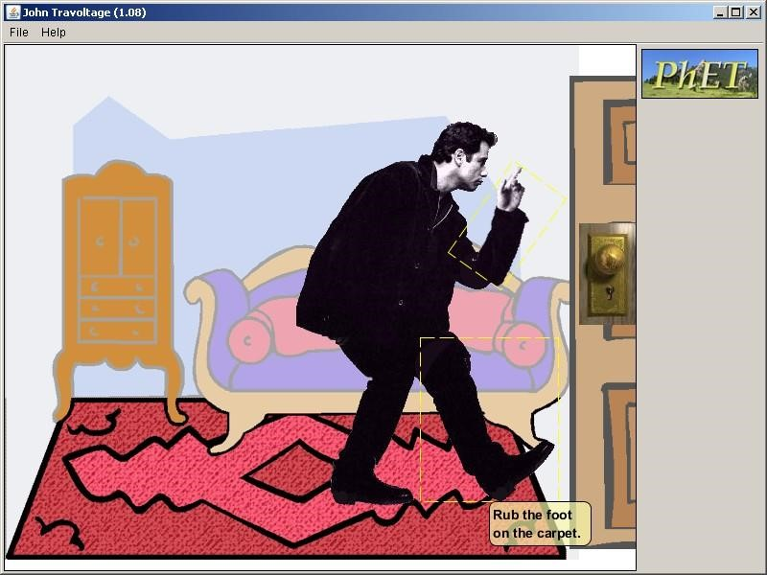

- Predict what will happen to John if he rubs his foot against the carpet.

- Rub John’s foot on the carpet by clicking and dragging his foot few times. What happens?

- Predict what will happen if John touches the door knob.

- Click and drag John’s hand such that it touched the doorknob. What happened?

- What would you call what happened to John?

- How is this different from the balloon and sweater or balloon and wall touching each other?

Ohm’s Law

Objectives:
- State Ohm’s Law. (CLO1)
- Use the correct units of current, voltage, and resistance in the metric systems. (CLO5)
- Explain the relationships between the variables in the Ohm’s Law formula (CLO2)(CLO3)
- Use Ohm’s Law to solve simple circuit problems (CLO5)
Procedure
Use the Ohm’s Law Simulator at https://phet.colorado.edu/en/simulation/ohms-law. Click the play button to start the simulator.

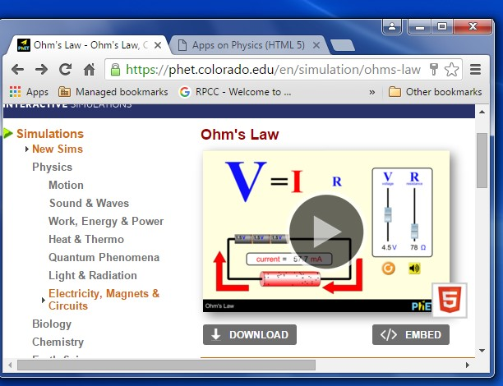

Data:
Familiarize yourself with simulator by adjusting the V and R sliders of the simulator.
Observe what happens when you move each slider. Decide on 4 values that you want to use for resistance. Write these values down.

For each resistor (keep the resistor slider fixed), change the voltage (U) 10 times. Record the values of voltage (V) and current (I). Make a table and record the values for V, I, and R.
Don’t forget you are collecting 10 voltages (V) and current (I) values for each resistor (R).
Data Analysis:
Plot a graph voltage versus current for each of the resistors. You should have 4 graphs.
What is the slope of each graph? What does this value represent?
Questions
- What happens to the value of the current (I) when the value of the resistance (R) increases?
- What happens to the value of the current (I) when the value of the voltage (V) increases?
- What is the relationship between the current (I) and the resistance(R)?

Conclusion:
What did you learn? Not what did you do!!

Resistance in Circuits

Objectives:
- Determine the electric resistance, voltage, electric current, and power in a circuit (CLO2)(CLO3)(CLO5)
- Discuss the relationship between energy, power, voltage, current, and resistance in a circuit. (CLO2)(CLO3)
- Describe and differentiate between parallel and series electrical circuits. (CLO2)(CLO3)
- Determine the equivalent resistance for series and parallel combinations of resistors. (CLO2)(CLO5)

Materials
Simulator at: https://www.walter-fendt.de/html5/phen/combinationresistors_en.htm

Data:
Before you do any simulations:
Choose 2 initial values for resistance. Write these values down. For all simulations keep the voltage at 12V.

Series Simulations:

For your 1st value of resistance:

Click on the Voltage and Amperage boxes. Next, click on the yellow portion of the screen as shown below.

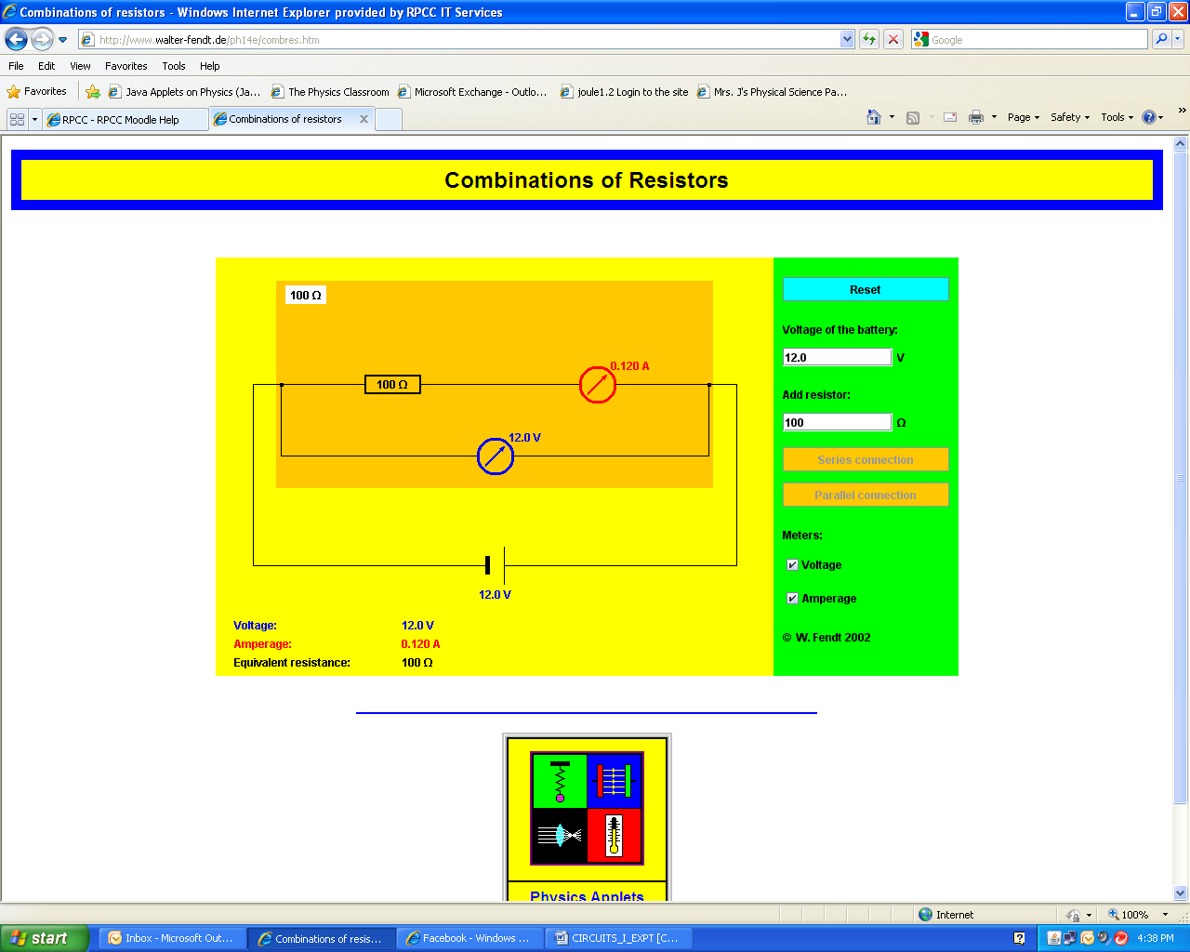
Click in the yellow area here

Record the voltage, current, and equivalent resistance in a table labeled 1st resistor series.

Click the Reset button twice. Click the series link once. You should now have two resistors (same value). Click on the Voltage and Amperage boxes. Next, click on the yellow portion of the screen as shown above.
Record the voltage, current, and equivalent resistance in the table labeled 1st resistor series.

Click the Reset button twice. Click the series link twice. You should now have three resistors (same value). Click on the Voltage and Amperage boxes. Next, click on the yellow portion of the screen as shown above.
Record the voltage, current, and equivalent resistance in the table labeled 1st resistor series.

Repeat the same process for your 2nd resistor. Label your table 2nd resistor series.

Parallel Simulations:

For your 1st value of resistance:

Click on the Voltage and Amperage boxes. Next, click on the yellow portion of the screen as shown below.

Click in the yellow area here

Record the voltage, current, and equivalent resistance in a table labeled 1st resistor parallel.

Click the Reset button twice. Click the parallel link once. You should now have two resistors (same value). Click on the Voltage and Amperage boxes. Next, click on the yellow portion of the screen as shown above.
Record the voltage, current, and equivalent resistance in the table labeled 1st resistor parallel.

Click the Reset button twice. Click the parallel link twice. You should now have three resistors (same value). Click on the Voltage and Amperage boxes. Next, click on the yellow portion of the screen as shown above.
Record the voltage, current, and equivalent resistance in the table labeled 1st resistor parallel.

Repeat the same process for your 2nd resistor. Label your table 2nd resistor parallel.

Data Analysis:

What happens to the voltage across each resistor in a series circuit as you add more resistors?

What happens to the voltage across each resistor in a parallel circuit as you add more resistors?

How do you find the equivalent resistance in a series circuit?

What happens to the current through each resistor in a series circuit as you add more resistors?

What happens to the current through each resistor in a parallel circuit as you add more resistors?

How do you find the equivalent resistance in a parallel circuit?

Conclusion:
What did you learn? Not what did you do!!

AC Circuits

Objectives:

- Determine the frequency, electric resistance, voltage, and electric current in a simple AC circuit (CLO2)(CLO3)(CLO5)
- Explain the function of a coil, resistor, and capacitor in a circuit (CLO2)(CLO3)

Procedure: Use the AC Circuit Simulator
http://www.walter-fendt.de/html5/phen/accircuits_en.htm
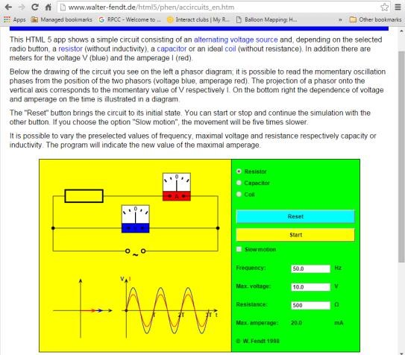

- Be sure to read the information and instructions on the simulator page.

- Choose the resistor element for the circuit.

Set your values for frequency, resistance, and max voltage.

Hit the START button. (You can choose the slow motion feature to observe the meters more closely)

Record the frequency, resistance, max voltage, and max amperage in a table.

Repeat for 5 different sets of values for frequency, resistance, and max voltage

Include the values in your table each time

What do you observe about the meters as the simulator runs?

- Next, choose the capacitor element for the circuit.

Set your values for frequency, capacitance, and max voltage.

Hit the START button. (You can choose the slow motion feature to observe the meters more closely)

Record the frequency, capacitance, max voltage, and max amperage in a table.

Repeat for 5 different sets of values for frequency, capacitance, and max voltage

Include the values in your table each time

What do you observe about the meters as the simulator runs?

- Next, choose the inductor element for the circuit.

Set your values for frequency, inductance, and max voltage.

Hit the START button. (You can choose the slow motion feature to observe the meters more closely)

Record the frequency, inductance, max voltage, and max amperage in a table.

Repeat for 5 different sets of values for frequency, inductance, and max voltage

Include the values in your table each time

What do you observe about the meters as the simulator runs?

Follow-Up: Use your observations, data and knowledge of AC circuits to answer the following questions about a simple AC circuit.

- What is a capacitor used for? What is a coil used for? What is a resistor used for?

- What does the term “AC” stand for? What is the general shape of the voltage and current vs. time curves? How does “AC” differ from “DC”?

- What is meant by the statement "the voltage across an inductor leads the current by 90º"?

- In general, which device allows more current to flow

- Coil
- Resistor
- Capacitor

5. What does the term RMS mean? What happens to the RMS current as the frequency increases?

