Faraday’s Law
Magnetism – Faraday’s Law

This assignment supports the following Course Goals, Course Learning Outcomes, and Unit Objectives:
Unit Objectives:
- Define: magnetic force (CLO1)(CLO2)(CLO3)
- Explain the effects of magnetic fields on moving charge (CLO2)(CLO3)
- Describe and differentiate between DC and AC current. (CLO2)(CLO3)
- Explain how a transformer works, and solve problems using the transformer formula. (CLO2)(CLO3)(CLO5)
- Describe how electric motors work and the role of magnetism in their function. (CLO2)(CLO3)

Introduction:
Michael Faraday was an English scientist that greatly contributed to the study of electromagnetism including building one of the first electric motors. He also contributed to how induction occurs. In this simulation, we will be experimenting with the process of induction.
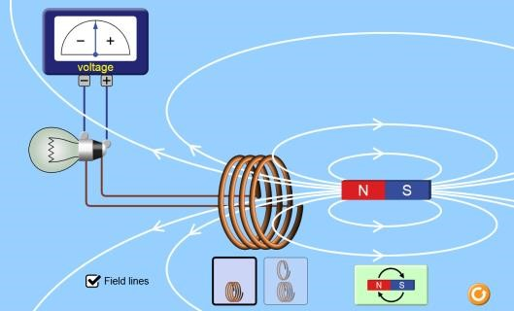
Directions:
- Click on the Simulation Link https://phet.colorado.edu/en/simulation/faradays-law
- Click on “Field Lines” to see the magnetic field around the magnet. Draw a sketch of what you notice.

- What happens as you move the north side of the magnet into the coil?

- How does the Voltage change as you move the south side in rather than the North?

- What happens if you move the magnet into the coil very slowly vs. very quickly. What relationship can you make between the motion of the magnet and the current produced?

- Can you produce a current when the magnet goes up and down in the loops?

- Next try two rings vs. four rings. What relationship can you make between the number of loops and the current produced.

- Lastly, try putting the magnet in the loops and click the magnet flip button. What happens as you spin the magnet several times?

- Look at the Voltage needle as you spin it multiple times. What type of current do you think it is producing? AC or DC?

