🧮 Dosage Calculation Practice Tools
1. Basic Dosage Formula Review
Formula:
Basic dosage formula review
Formula:
Dose to give= (Desired Dose (D) / Have (H)) x Quantity (Q)
Example: Order: 500mg
Available: 250mg tablets
(500/250) x 1 = 2 tablets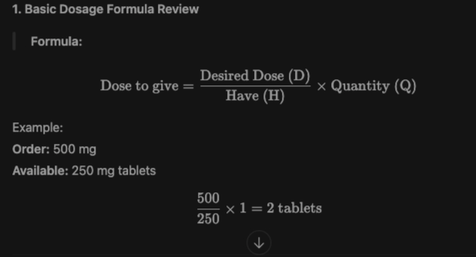

2. IV Flow Rate Calculation
Formula (mL/hr):
IV Flow Rate Calculation
Formula (mL/hr):
Total Volume (mL) / Tiime (hr) = mL/hr
Formula (gtt/min):
(Volume (ml) x Drop Factor (gtt/mL)) / Time (min)
Example:
Infuse 1000 mL over 8 hours.
1000 / 8 = 125 mL/hr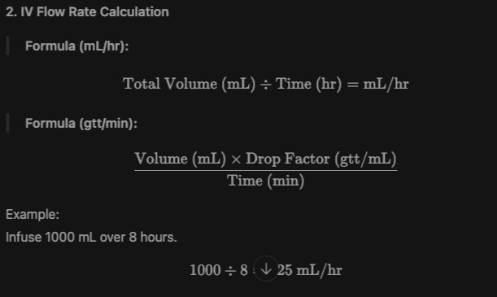

3. Dimensional Analysis Template
Start with what you’re asked to find, and cancel units:
mg x (1 tab / 250 mg) = tabs
