Lab 11: Anatomy of Digestion

Learning outcomes of the lab exercises:
- Identify the structures and organs of the digestive system using the laboratory models
- Define the main function of each of the digestive system organs
- Compare and contrast the histological features of the tissues in the esophagus, liver, small and large intestine

“The function of the digestive system is to break down the foods you eat, release their nutrients, and absorb those nutrients into the body. Although the small intestine is the workhorse of the system, where the majority of digestion occurs, and where most of the released nutrients are absorbed into the blood or lymph, each of the digestive system organs makes a vital contribution to this process.” OpenStax A&P, pg 1086

Organs of Digestion

You must be able to identify all of the terms in bold on models for the lab exam.

Oral Cavity
- The function is to ingest food. The mouth begins the process of digestion by secreting saliva and mechanically grinding food.
- the mouth, or oral cavity extends from the lips anteriorly to its junction with the oropharynx posteriorly. Important contents of the oral cavity are:
- teeth
- tongue
- hard and soft palate
Salivary glands
- parotid gland and duct
- submandibular gland
- sublingual gland

OpenStax A&P, pg 1100

Oropharynx & Laryngopharynx
- oropharynx connects the oral cavity to the pharynx
- laryngopharynx continues openings of larynx (at epiglottis) and esophagus
- reviewed in the respiratory system

Esophagus
- The function is to conduct swallowed food from the pharynx above to the stomach below.
1. Esophageal (cardiac) sphincter

Stomach
- The functions include the storage, some digestion, and release of food into the duodenum.
- The cardia is the region nearest to the entrance of the esophagus.
- The fundus is the pocket that is superior to the cardia.
- The main midportion of the stomach is the body.
- The antrum is the lower, muscular portion of the stomach. The antrum is also known as the pyloric region of the stomach.
- The greater curvature is the convex lateral side of the stomach.
- The lesser curvature is the concave medial side of the stomach.
- The pyloris is the pocket nearest the end of the stomach, the pyloric sphincter is a valve that connects the stomach to the small intestine.
- Inside the stomach are wrinkly folds of tissue known as rugae. The rugae allow the stomach to expand when food enters the organ

OpenStax A&P, pg 1108

Small Intestine
- Nearly all absorption of nutrients occurs in the small intestine. To increase absorptive area the small intestine displays many lumenal modifications, including finger-like projections known as villi.
- The proximal portion of the small intestine is the duodenum.
- The middle segment of the organ is the jejunum.
- The distal portion of the small intestine is the ileum.

OpenStax A&P, pg 1114

Large Intestine
- Little or no digestion takes place in the large intestine (unless due to activity of the gut microbiome); its function is largely water and electrolyte absorption. During the process of compaction, mucus secretion by goblet cells eases movement of fecal material as it forms.
- The proximal portion of the large intestine in the cecum.
- The vermiform appendix attaches to the cecum.
- The colon is divided into several regions including the ascending colon, transverse colon, descending colon and sigmoid colon.
- The rectum is the distal portion of the large intestine.
- The anus is the opening to the exterior.
OpenStax A&P, pg 1119

Pancreas
- The head of the pancreas sits in curvature of the duodenum.
- The pancreatic duct joins the bile duct before emptying into small intestine
- Digestive products released by the liver and pancreas enter the small intestine at the major ampulla.

Liver
- The liver is composed of four lobes: the left lobe, the right lobe, the caudate lobe, and the quadrate lobe.
- The falciform ligament is a mesentery that helps to separate the left and right lobes and attaches the liver to the diaphragm.
- Secreted bile travels through bile canaliculi toward the hepatic duct.

Gall Bladder
- The gall bladder sits deep to the left lobe of the liver.
- The cystic duct joins the common hepatic duct to form the common bile duct.

OpenStax A&P, pg 1124

Microscope Exercise

- Esophagus –Examine a slide of esophagus, identify the following features, sketch and label what you see in the space below:
  - Mucosa (stratified squamous epithelium)
  - Submucosa (areolar connective tissue, contains mucous glands)
  - Muscularis externa (circular layer, longitudinal layer)
  - Advertitia (fibrous connective tissue)

- Stomach - Examine a slide of stomach, identify the following features, sketch and label what you see in the space below
- Mucosa (simple columnar epithelium, gastric pits, gastric glands)
- Submucosa (areolar connective tissue)
- Muscularis externa (circular layer, longitudinal layer)
- Serosa (fibrous connective tissue)

- Small Intestine - Examine a slide of small intestine, identify the following features, sketch and label what you see in the space below:
- Plicae circularis (circular folds)
- Intestinal villi
- Mucosa (simple columnar epithelium with microvilli)
- Submucosa (areolar connective tissue)
- Muscularis externa (circular layer, longitudinal layer)
- Serosa (fibrous connective tissue)

4. Large Intestine - Examine a slide of large intestine, identify the following features, sketch and label what you see in the space below:
- Intestinal villi
- Crypts
- Mucosa (simple columnar epithelium, goblet cells)
- Submucosa (areolar connective tissue)
- Muscularis externa (circular layer, longitudinal layer)
- Serosa (fibrous connective tissue)

5. Liver – The liver’s structural and functional units are called lobules. Each lobule is a roughly hexagonal structure consisting of plates of liver cells. The liver cell plates radiate outward from a central vein running within the longitudinal axis of the lobule. Between the liver cell plates are enlarged capillaries called liver sinusoids. Examine a slide of large intestine, identify the following features, sketch and label what you see in the space below:
- Lobules
- Liver cells
- Central vein
- Sinusoids

Digestive Anatomy Coloring
Word Bank
Tongue | Ascending colon | Stomach | Gall bladder
Parotid gland | Transverse colon | Duodenum | Pancreas
Sublingual gland | Descending colon | Jejunum | Oropharynx
Submandibular gland | Sigmoid colon | Ileum | Diaphragm
Esophagus | Rectum & Anus | Cecum | Oral cavity
Left lobe of liver | Right lobe of liver | Appendix | Common Bile Duct

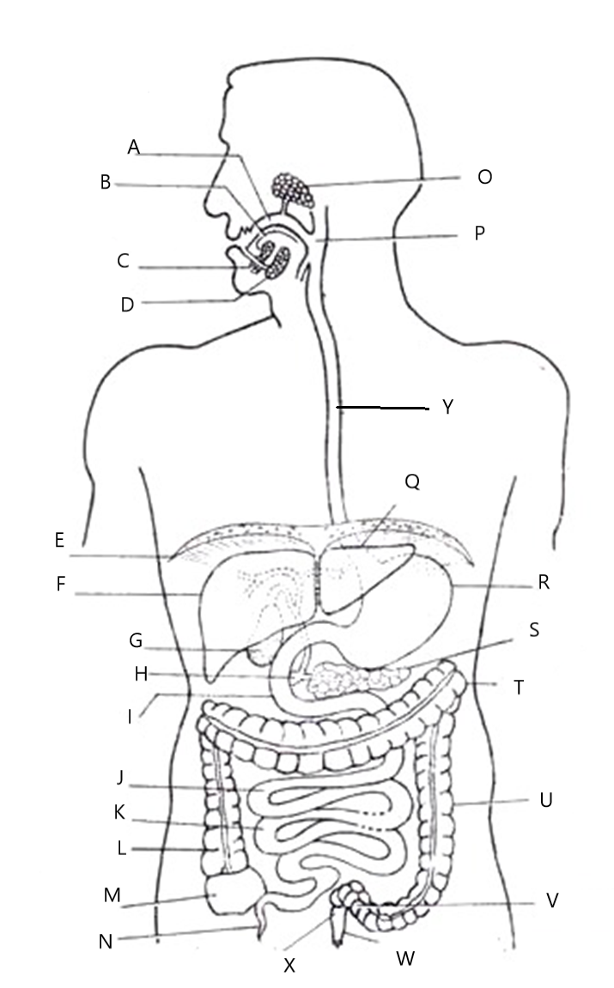
http://www.biologydiscussion.com/human-physiology/human-digestive-system/main-parts-of-human-digestive-system-with-diagram/5238
Stomach Image to Label

Word Bank
Pyloric sphincter | Esophageal sphincter
Cardia | Body
Fundus | Pyloris
Lesser curvature | Greater curvature
Duodenum | Esophagus

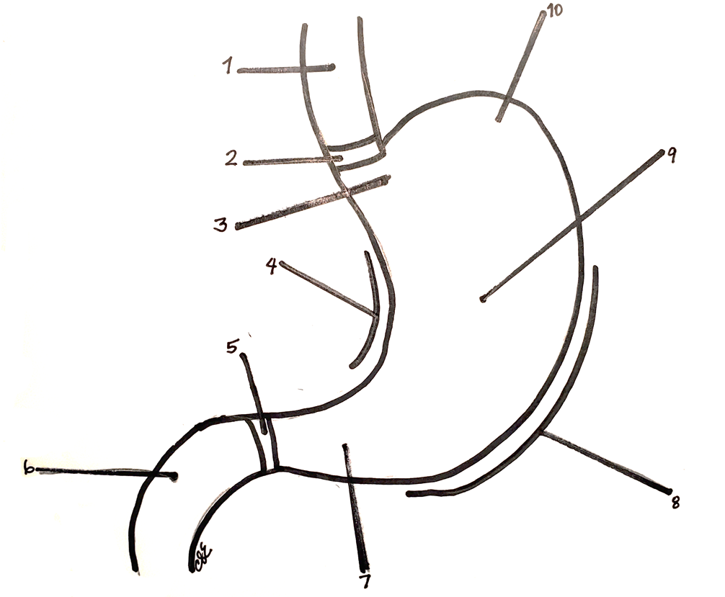

Liver, Pancreas, and Ducts Image to Label

Word Bank
Falciform ligament | Right lobe of liver
Left lobe of liver | Gall bladder
Hepatic ducts | Cystic duct
Pancreas | Pancreatic duct
Duodenum | Common Bile Duct
Caudate lobe of liver

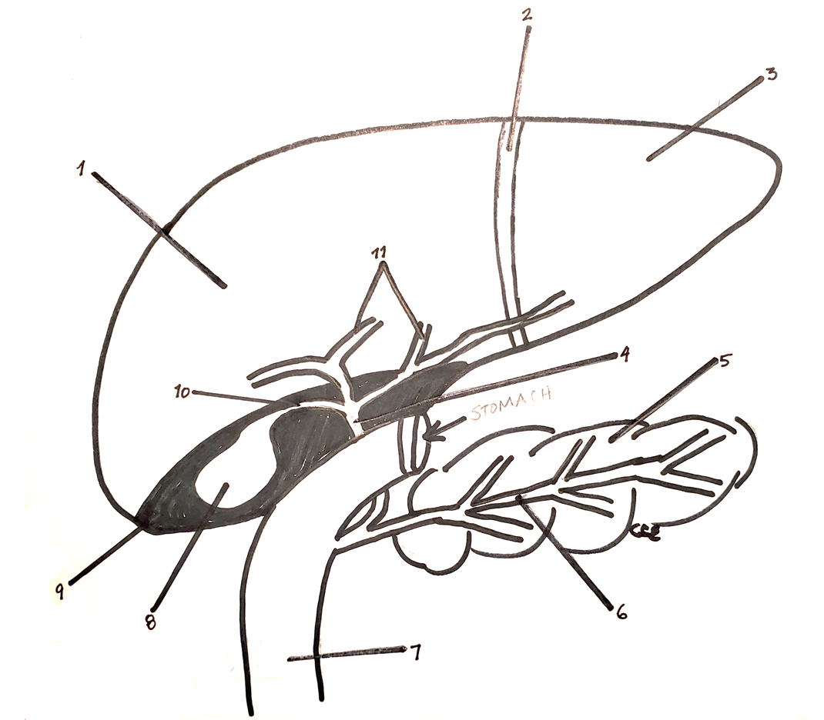
Digestive Anatomy Word Bank

Digestive Models
Tongue | Ascending colon
Parotid gland | Transverse colon
Sublingual gland | Descending colon
Submandibular gland | Sigmoid colon
Esophagus | Rectum
Stomach | Liver
Greater curvature | Gall bladder
Lesser curvature | Pancreas
Esophageal sphincter | Pancreatic Duct
Pyloric sphincter | Appendix
Cardia | Haustrum
Fundus | Cystic Duct
Body | Hepatic Duct
Pyloris | Common Bile Duct
Rugae | Falciform Ligament
Small intestine | Right Lobe
Duodenum | Left Lobe
Jejunum | Caudate Lobe
Ileum | Quadrate Lobe
Large intestine | Spleen

Matching Exercise
Match the digestive structure to its proper function.

 | ____ | Esophagus | [A] | Stores bile produced by the liver
 | ____ | Stomach | [B] | Connects the oral cavity to the pharynx
 | ____ | Small Intestine | [C] | Function is to conduct swallowed food from the pharynx above to the stomach below
 | ____ | Large Intestine | [D] | Distal portion of the large intestine
 | ____ | Gall Bladder | [E] | Largest of the salivary glands, located superficial to the masseter muscle
 | ____ | Liver | [F] | Proximal portion of the small intestine
 | ____ | Pancreas | [G] | Muscle used to manipulate food in the oral cavity
 | ____ | Common Bile Duct | [H] | Function is to ingest food. The mouth begins the process of digestion by secreting saliva and mechanically grinding food
 | ____ | Ileocecal junction | [I] | Function is absorption of nutrients, as nearly all nutrients are absorbed using villi in this organ
 | ____ | Rectum | [J] | Connection between the ileum of the small intestine and the ascending colon of the large intestine
 | ____ | Oral cavity | [K] | Functions include the storage, some digestion, and release of food into the duodenum.
 | ____ | Parotid gland | [L] | Endocrine function is glucose homeostasis; in digestion secretes trypsin, amylase, lipase & bicarbonate
 | ____ | Oropharynx | [M] | Tube that is created as the hepatic and cystic ducts combine and transport bile to the duodenum
 | ____ | Tongue | [N] | Function is to absorb water, produce flatus, and compact fecal material; storing the feces until it can be released
 | ____ | Duodenum | [O] | Largest gland of the body that performs a variety of metabolic functions including plasma protein synthesis

Activity: Complete the Story of Movement through the Digestive Tract

 | Anus |  | Ileum |  | Rectum
 | Ascending Colon |  | Ileocecal Junction |  | Rugae
 | Cecum |  | Jejunum |  | Saliva
 | Descending Colon |  | Oropharynx |  | Sigmoid Colon
 | Duodenum |  | Pancreas |  | Sublingual Gland
 | Esophageal Sphincter |  | Parotid Gland |  | Submandibular Gland
 | Gall Bladder |  | Peristalsis |  | Transverse Colon
 | Hydrochloric Acid |  | Pyloric Sphincter |  | Villi
When a person smells food, the process of digestion begins. The stomach begins to fill with _(1)_ acid, and the mouth produces _(2)_ in preparation for the upcoming meal. In the mouth, digestion begins with the three salivary glands _(3)_, _(4)_, and _(5)_ produce saliva. The food is chewed and swallowed is now called a bolus, through the _(6)_ and moves down the esophagus by _(7)_. At the diaphragm, the esophagus joins the stomach through a connection called the _(8)_.
Once inside the stomach, the bolus of food is able to expand the stomach because of the wrinkly walls called _(9)_. The stomach liquefies the food into a solution known as chyme. This liquid then exits the stomach through the _(10)_ sphincter, which only allows a small amount of the fluid into the start of the small intestine, the _(11)_. Once the acidic chyme is sensed to be in the small intestine, hormones released will regulate the secretion of bile from the _(12)_ and pancreatic juices from the _(13)_. These new enzymes now enter the duodenum and neutralize the chyme.
The middle section of the small intestine known as the _(14)_ is where absorption of nutrients occurs with the increased surface area produced by _(15)_, the microscopic finger-like projections from the internal surface of the intestinal tract. The final segment of the small intestine is known as the _(16)_, where the chemical breakdown of food by enzymes is completed. Next, material moves through the _(17)_ and into the first region of the large intestine at the _(18)_, junction.
The main job of the large intestine is to compact the material and create fecal material through compaction. The large intestine has four segments, _(19)_, _(20)_, _(21)_ and _(22)_. After the fecal material travels to the end of the large intestine, it is stored in the sigmoid colon before being released through the _(23)_ and the _(24)_.

Problem Solving Activity
For each response,
[1st] State whether you are ACCEPTING or REJECTING that statement.

[2nd] Write a detailed explanation WHY you ACCEPT or REJECT ALL of the choices.
The following problem-solving assessment is presented in a multiple-choice format. Each choice should be considered individually and an argument should be written for accepting or rejecting it. Since the problem has one best answer, there should be one argument for acceptance and four for rejection.

PROBLEM:

A middle-aged professor complains of burning pain in the "pit of her stomach," usually beginning about two hours after eating and abating after drinking a glass of milk. When asked to indicate the site, she points to her epigastric region. Her GI tract is examined by X-ray fluoroscopy and a gastric ulcer is identified. A selective vagotomy (cutting the vagal fibers serving the stomach) is recommended.

- Gastrin will no longer be secreted by the stomach or duodenum.

- Activity of the sympathetic division of the autonomic nervous system will be increased.

- There will be a general reduction in secretory activity of the stomach.

- The cephalic phase of gastric secretion will be intensified.

- Digestion processes normally occurring in the stomach will cease.

Case Study- The Case of the Missionary Health Care Worker in Africa

Case Background
Jenny, a 22-year-old college graduate, has recently decided to spend two years as a missionary in a coastal African village. As part of her duties, she will work in the missionary clinic that has recently been established in the village. This clinic will provide routine medical care and a travelling physician and nurse will visit once each week. Jenny feels fortunate to have the opportunity to use the information that was presented to her in various classes she completed while in college. After completing a 4-month intensive training period (language classes, medical preparation for work in the clinic, and cultural enrichment), she departed for Africa.
Upon her arrival, Jenny found that she would be spending most of her time in the clinic since the village had been without routine medical care for the past 2 years. The previous clinic was closed due to flooding and insufficient funds to rebuild. Initially, Jenny found that she was very dependent upon the physician's weekly visits since her training was limited. Gradually, she found that she was beginning to call upon her training (both clinical and classroom) and she felt comfortable diagnosing and treating some of the more routine cases.
Case Presentation
One morning, a mother came in with her five-year-old child. The mother reported that the child had been unable to eat or drink anything for the past day because of vomiting. In addition, her child was experiencing severe diarrhea. Jenny asked the mother if any other family members were exhibiting similar symptoms, to which the mother replied that a few other members of the family had similar symptoms, however, not as severe.
Jenny's first thought was that the symptoms were very similar to those she had exhibited following a bout of food poisoning while in college. Since the villagers had no refrigeration and poor sanitation, Jenny gave the mother an electrolyte solution containing glucose similar to Gatorade® and told the mother to have the affected children consume this solution and nothing else for the next 24 hours. After that time, if the children were no longer vomiting, she could start feeding them tea and broth. Jenny also cautioned the mother that if the children did not seem to be getting better after 24 hours to bring the children back to the clinic.
Diagnosis
The next morning Jenny opened the clinic to find the mother, and not just the child she had seen the previous day, but three more of the woman's children. All of the children were exhibiting similar symptoms that now included muscle cramping and excessive thirst in addition to diarrhea and vomiting.
When checking the vital signs of the children, Jenny noticed increases in both the pulse and respiratory rates accompanied by decreased blood pressures. Uncertain as to the appropriate course of action, Jenny contacted the physician by radio. Upon conveying the histories and information to the physician, Jenny received instructions to keep the children at the clinic, start intravenous (IV) infusion with lactated Ringer's solution, and allow the children to drink as much of the electrolyte solution with glucose as they would like.
The physician also gave Jenny a list of laboratory tests to run on the blood, urine and that she should collect.
Jenny started the IV infusions and gave each child some of the electrolyte solution. After this, she obtained stool, blood and urine samples from each child and asked the mother to leave the children with her for care and observation. The mother agreed and said she would return later that night to help with the children.
Test Results
The results of the tests run indicated severe metabolic acidosis, an increased hematocrit, hypokalemia, and the presence of Vibrio cholerae bacteria in the stool samples.
Based on the results of these tests, the physician and Jenny diagnosed the children with cholera and obtained a more detailed history in an attempt to determine whether these individuals were the only ones exposed or whether these cases were the first of a possible epidemic.
Jenny and the physician found that the family had recently visited relatives in a distant village where similar symptoms had been present in many families that had all celebrated a recent shellfish harvest.
Treatments
The physician prescribed continued IV infusions with lactated Ringer's solution and electrolyte fluid replacement by mouth.
The children were not allowed to consume other foods or drinks, especially coffee or any other beverages containing caffeine.
The children were also told that once the vomiting stopped, they could start consuming solid foods.
The children were all treated with antibiotics and stool samples were taken from other family members to determine whether they were infected with Vibrio cholerae. Infected, asymptomatic individuals were treated with antibiotics.
The physician later explained to Jenny that caffeine was prohibited because the toxin produced by the bacteria (termed choleragen) binds to the surface of the epithelial cells of the small intestine and activates adenylate cyclase. In addition, the toxin interferes with the active transport of sodium ions in the intestinal lumen.
Answer the following questions in complete sentences. Be sure to use details from the case to answer the questions about Jenny.
1] Why did Jenny initially suspect that the child and the other family members were experiencing food poisoning?

2] Why did Jenny initially prescribe an electrolyte solution containing glucose?

3] Upon further evaluation on the second day why would the children present with an increased pulse and respiratory rate but a decreased blood pressure?

4] Why did the children present with metabolic acidosis?

5] Why were the children experiencing muscle cramping and complaining of excessive thirst on the second day?

6] Why were the children not allowed to consume any caffeine containing beverage?

7] Why does the effect of the cholera toxin on the epithelial sodium transport protein contribute to both the diarrhea and metabolic acidosis?

